**Microsoft Azure Virtual Training Day: Azure Fundamentals Day 1**

Online free training from MS 15/09/2021

Contents

Resources 2

Introduction – Day1 3

Module 1 - Azure Cloud Concepts​ 4

Cloud Models 4

Module 2 - Azure Core Services 10

Availability Options 12

Azure Resources 13

Azure Portal 14

Azure Compute Services 17

Virtual Machines 17

Create VM 17

PaaS 26

Windows Virtual Desktop 32

Virtual Network & Machines 32

Azure Database Services 42

Azure Marketplace 43

Module 3 - Azure Solutions and Management Tools 45

Internet of Things 45

Big Data Analytics 45

AI & ML 46

DevOps & GitHub 46

Azure Management Tools 47

Azure Resource Manager (ARM) 48

Advisor in Azure Portal 52

# Resources

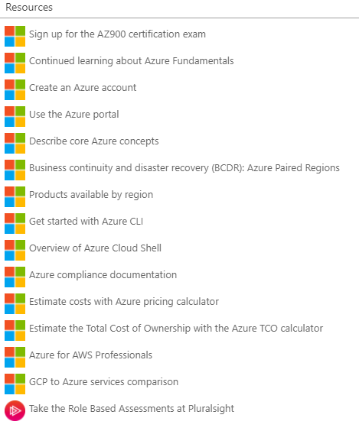

Info

**Welcome!**

Hello everyone! Thank you for joining the Azure Fundamentals Training day today. There is a list of resources available on your screen now. Please feel free to ask the live moderator questions within this chat box. If you are having technical issues, please click the question mark, Help widget on your screen now. Please do keep an eye on the Microsoft UK Training Days webpage for more events coming up <https://www.microsoft.com/en-gb/events/training-days>/ . Enjoy the session! – 'The Microsoft Training Days' Event Team

**Exam Information**

Once you have completed all of this training you are eligible to take the AZ-900 certification exam at no cost. You will receive a 'Thank You' email in the next 5 working days with steps on how you can claim and schedule your exam. You have 90 days from after the session to schedule the exam. The exam will be online and you will have 40-60 multiple questions with 60 minutes to complete. You have one attempt to pass the exam for free, after this there will be a cost of $99 but we are sure you will pass first time! There are no official Microsoft practice exams. There are several paid options available through LinkedIn Learning, Measure Up, and a number of other providers. However, we recommend that you check out the knowledge checks at the end of each of the modules in the learning path which is the first link in your resources box. Good Luck!

**Agenda**

10.00 – 10.03 ​ Introduction​ 10.03 – 11.13 ​ Azure Cloud Concepts​ Core Azure Services​ 11.13 – 11.23​ Break-10 minutes​ 11.23 – 11.40 ​ Azure Solutions and Management Tools​ 11.40 – 12.10 ​ Closing Q&A​

# Introduction – Day1

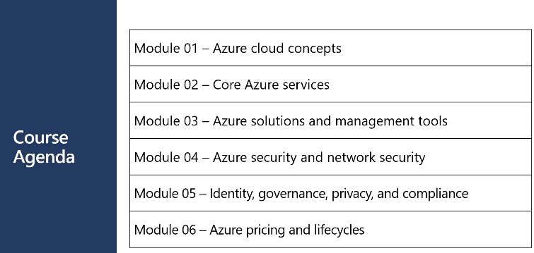

Exam – 60 mins multi-choice

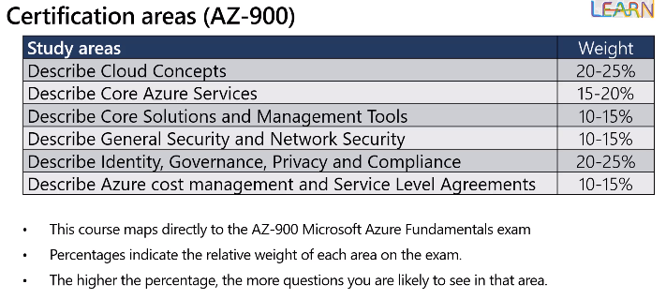

# Module 1 - Azure Cloud Concepts​

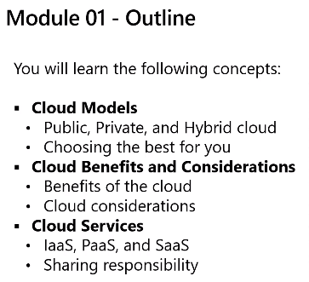

## Cloud Models

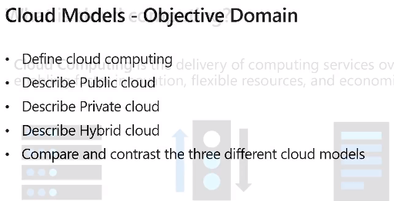

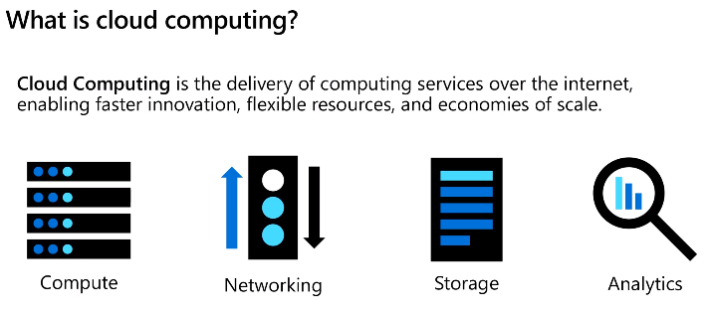

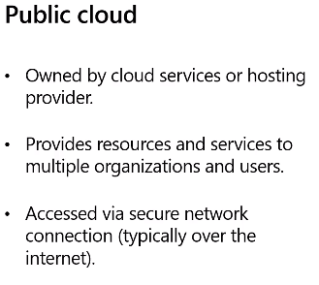

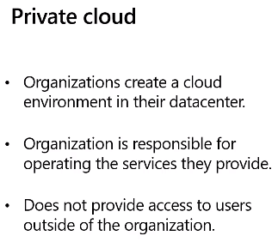

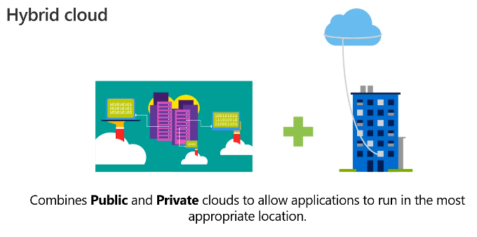

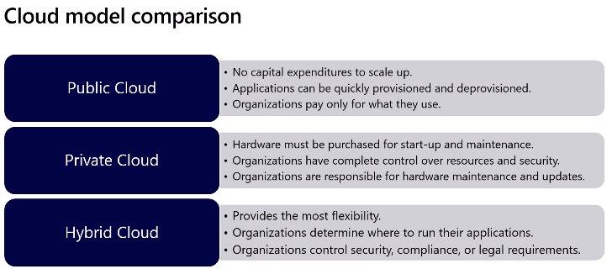

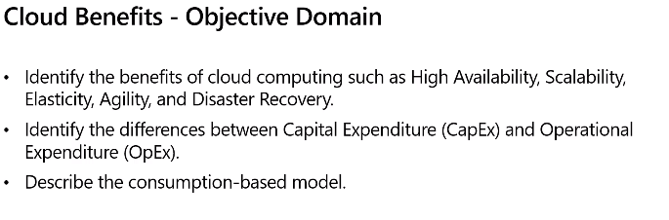

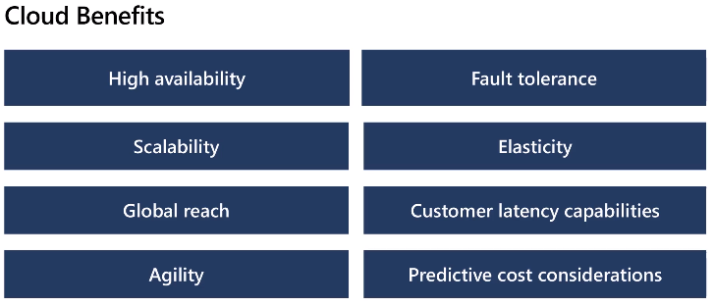

Scaling out – adding more resources

Scaling up – adding to existing resources cpu or memory

Agility ramp up/down

Elasticity similar to scalability but auto increase/decrease as required (e.g. day/night)

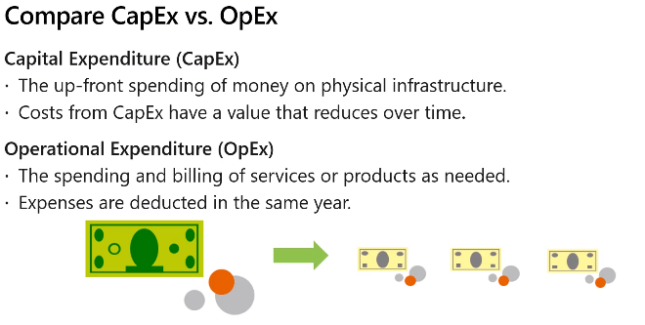

Cloud is pretty much OpEx

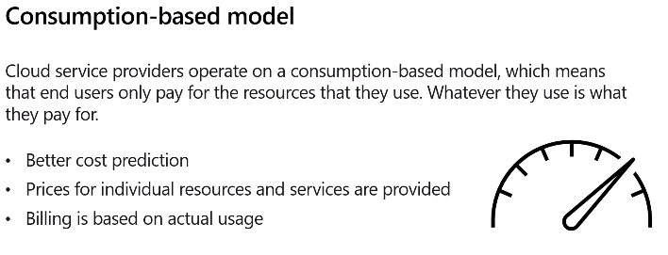

Saves sizing (costs) all resources for known spike

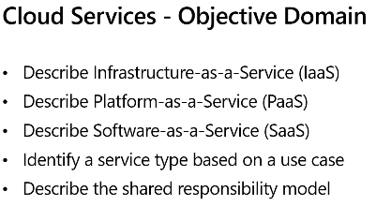

VMs = IaaS model

O365 = SaaS

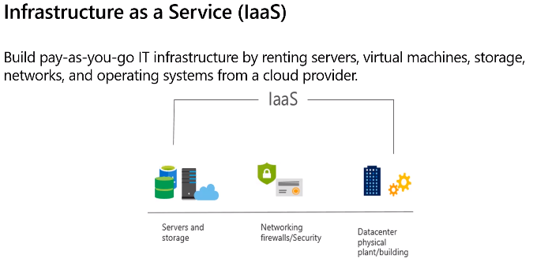

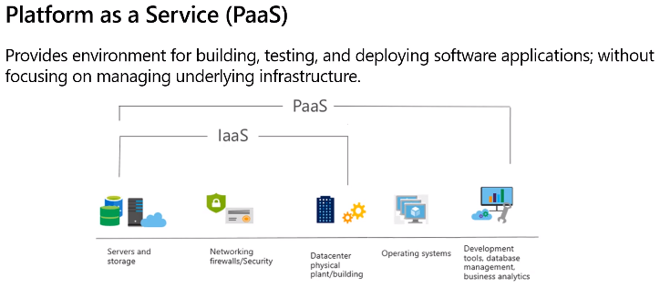

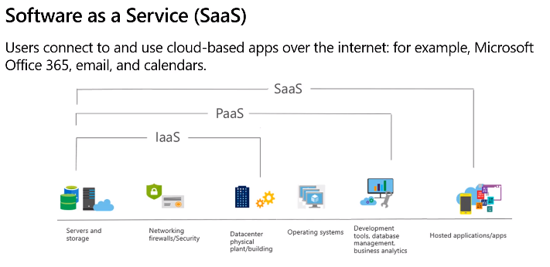

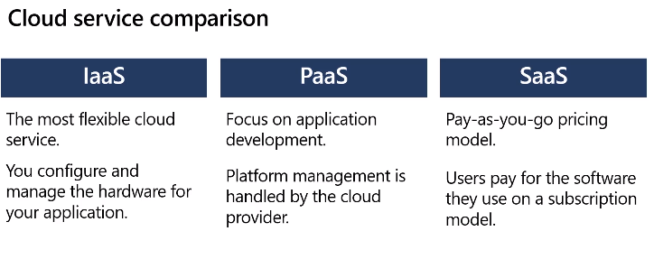

IaaS = flexibility

PaaS = productivity, organisation concentrates on development

SaaS = subscription

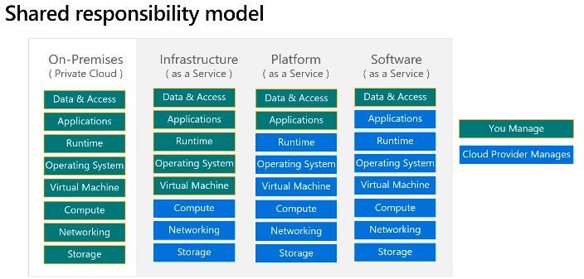

# Module 2 - Azure Core Services

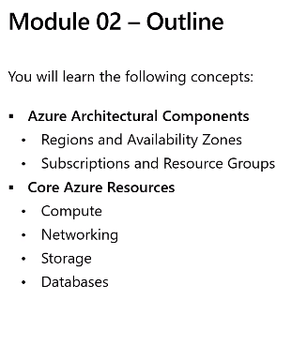

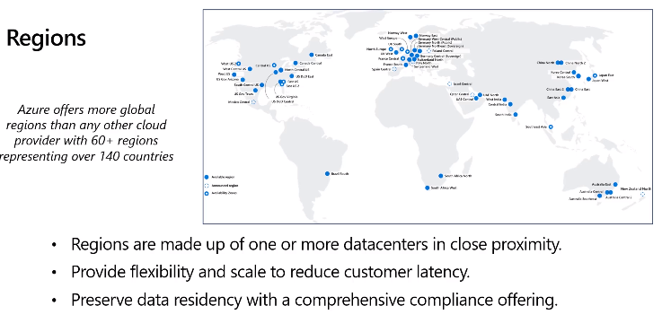

Close region = low latency

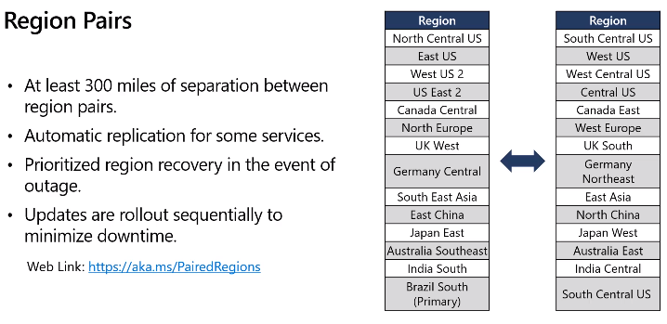

Pick auto Region Pairs wherever possible

So if every outage one pair will be prioritised

Updates go to 1 pair at a time

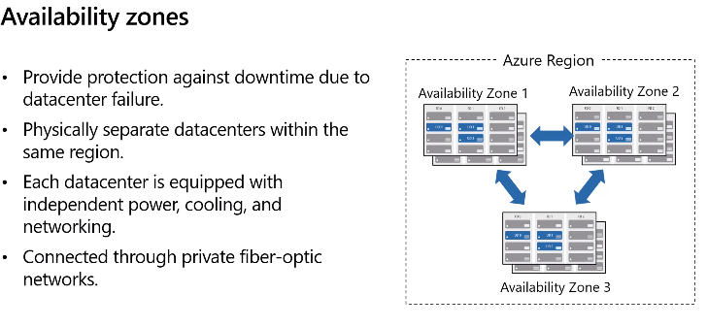

Not all regions have the same availabilities

Azure in Dublin Ireland (5 data centres within)

**Physical**

Fenced wall all round, gate, security camera, drive design roundabout, bends so cannot build speed. Need appointment to get in.

1 availability zone with 3 independent data centres with their own power, cooling, network.

## Availability Options

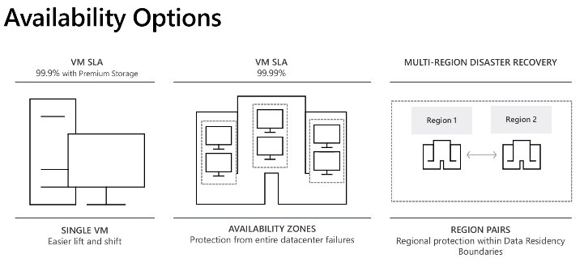

## Azure Resources

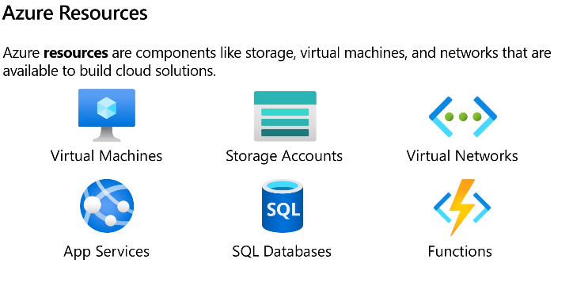

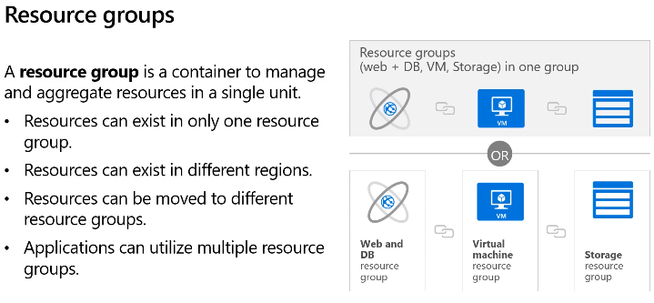

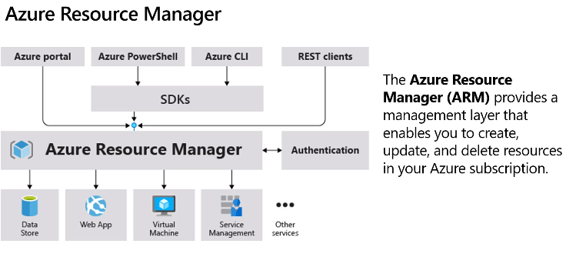

Can auto deploy using different tools (top line)

Help maintain consistency and standardisation – ARM template to ensure all same

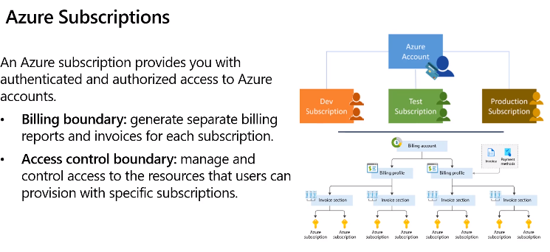

Account can have multiple subscriptions

Subscription – billing boundary & access control boundary

## Azure Portal

Home page - portal

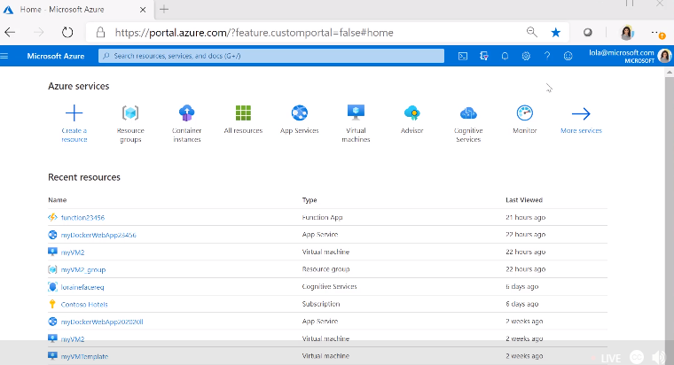

Setting – set home page, etc as you want

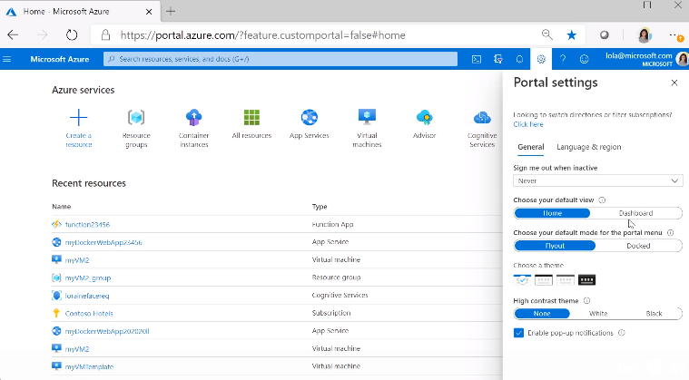

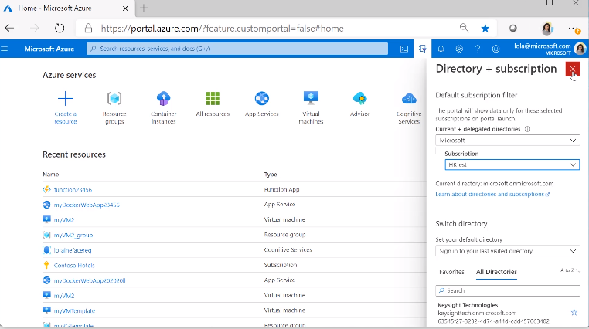

Cloud shell button on RHS of search bar – pops up dev window

LHS dashes menu = main menu

Star the favourites

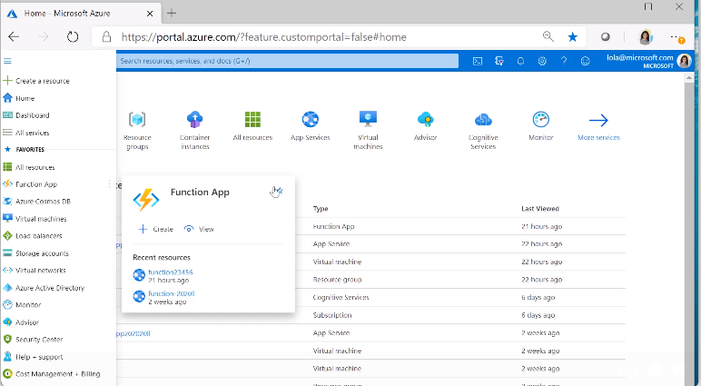

Dashboard

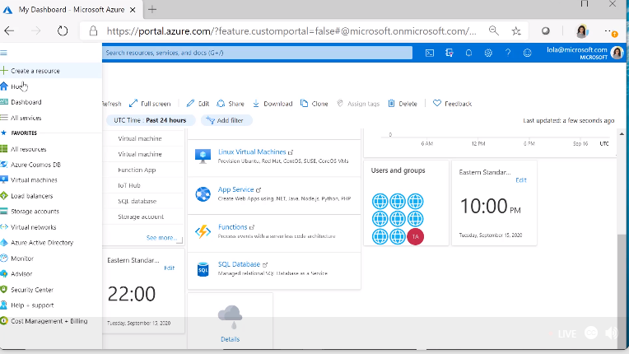

## Azure Compute Services

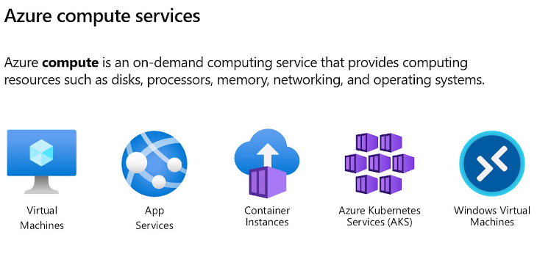

### Virtual Machines

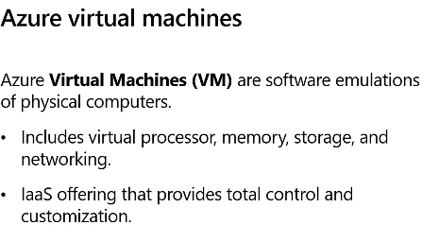

Auto elastic benefit – scale out/in as needed

### Create VM

Select Compute from menu

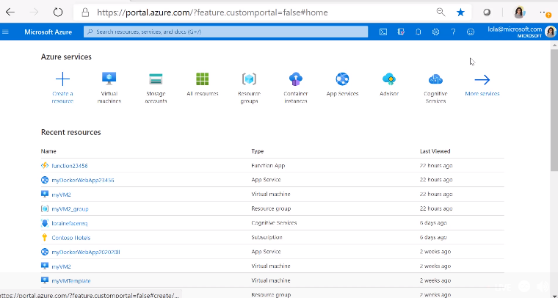

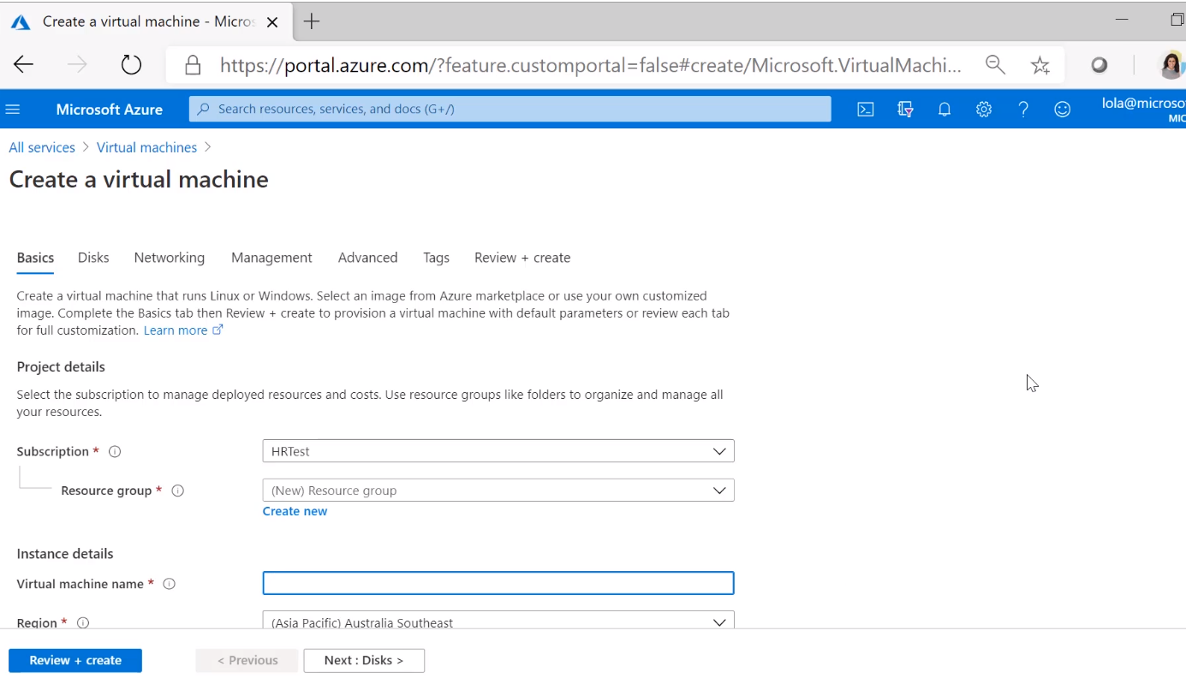

Create a new resource group

Create Name

Pick Region near to you

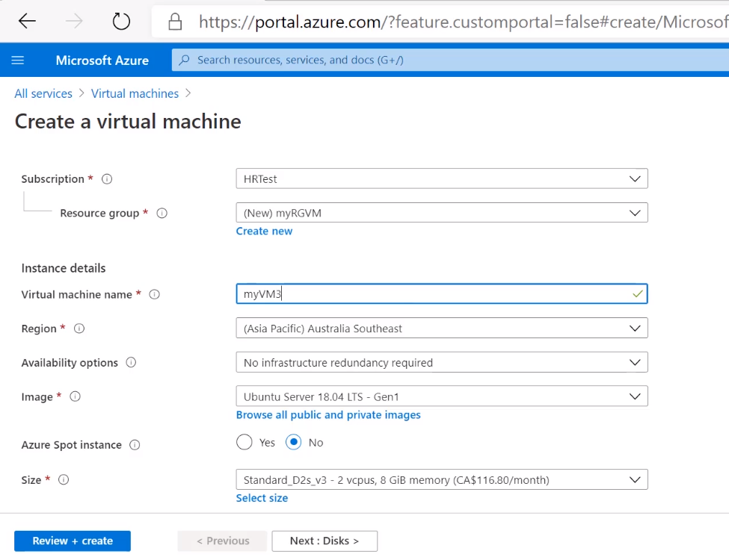

Availability set – different rack in same data centre

Availability zones – different data centres

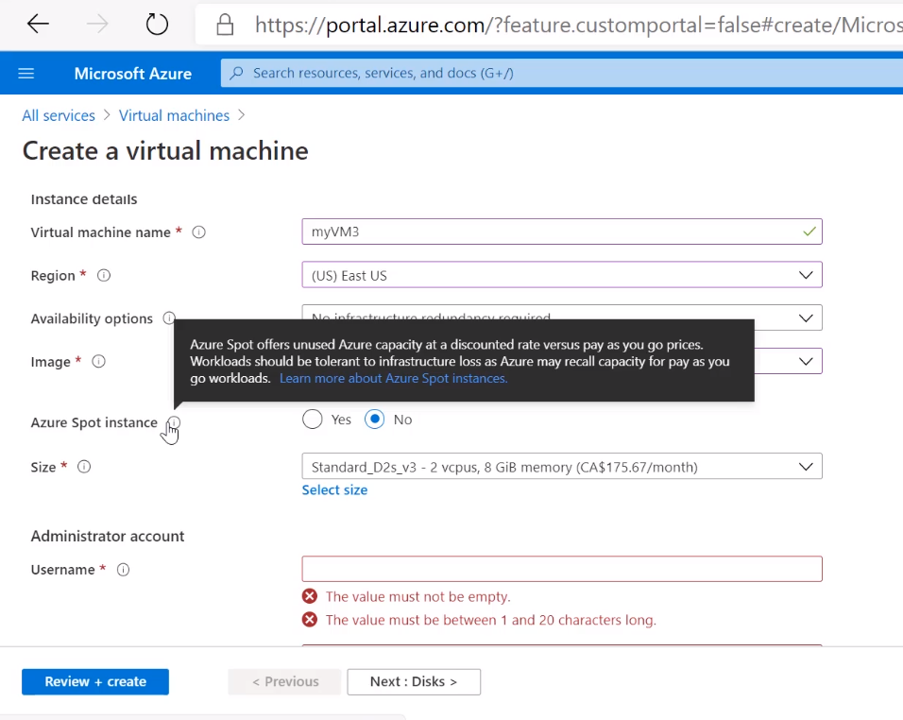

Set inbound ports – so can access VM

What ips can access

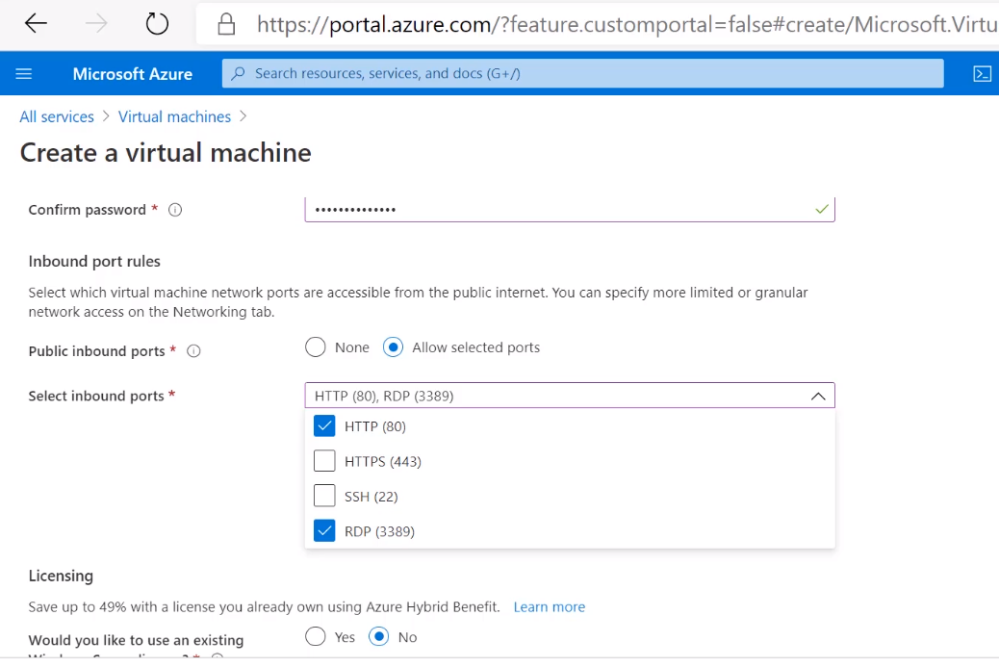

Storage

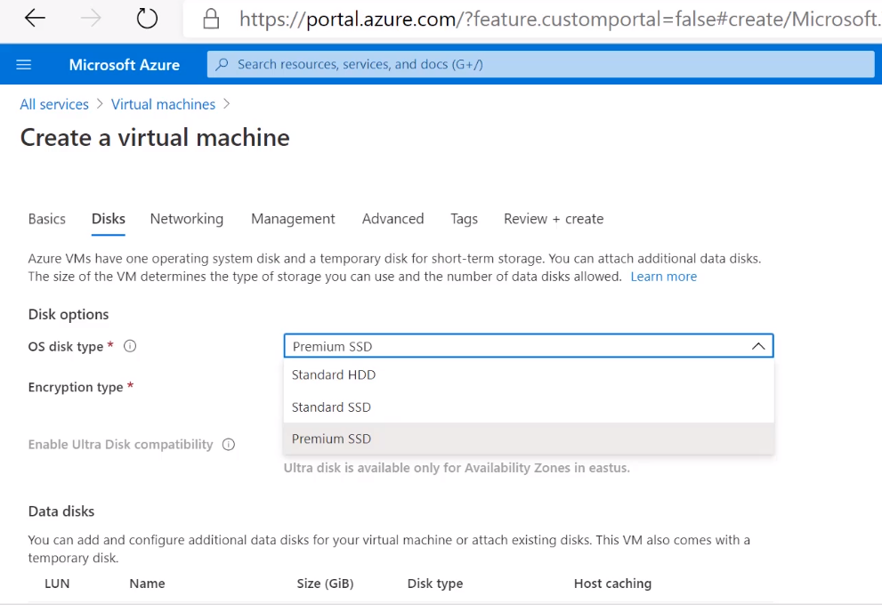

Networks so can get to ports and get public ip

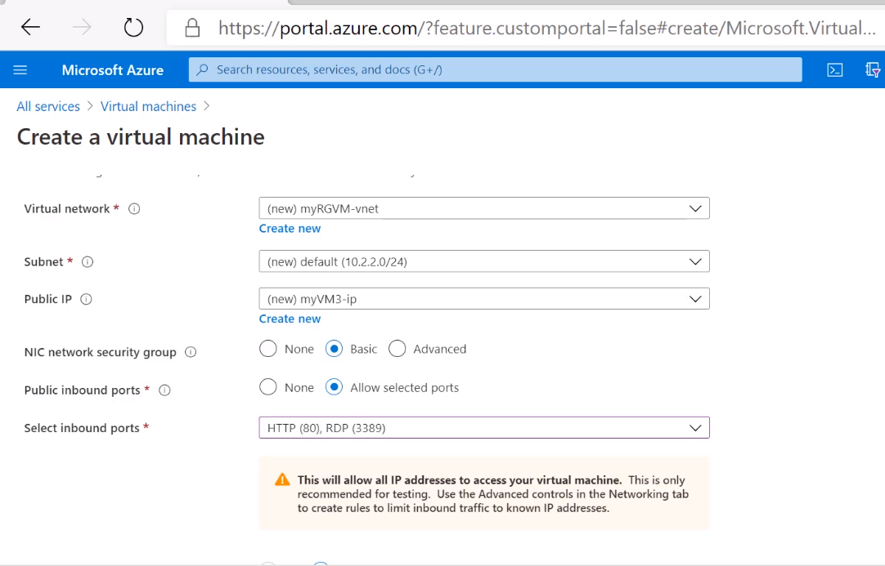

Various options

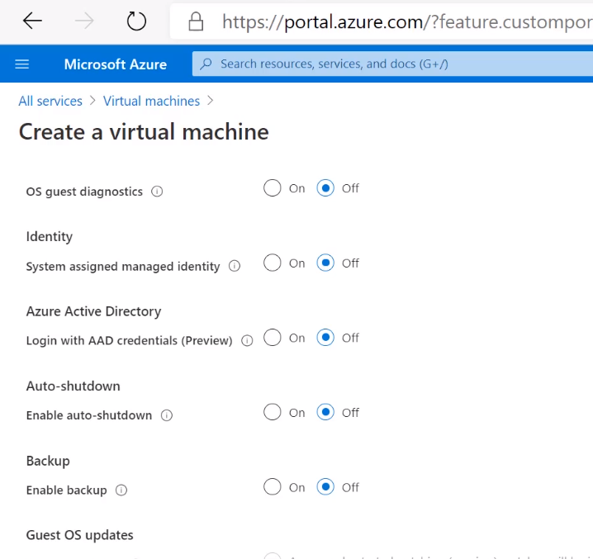

Advanced

Can add tags to split subscription into projects (searching and charging

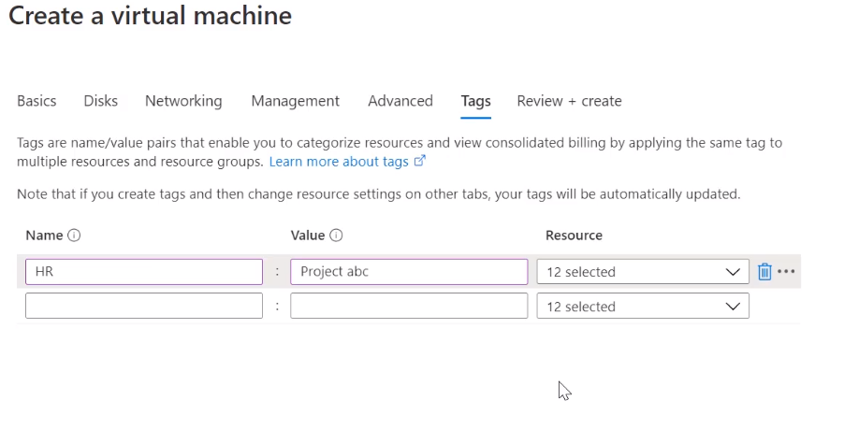

Can save temple to use for other VMS

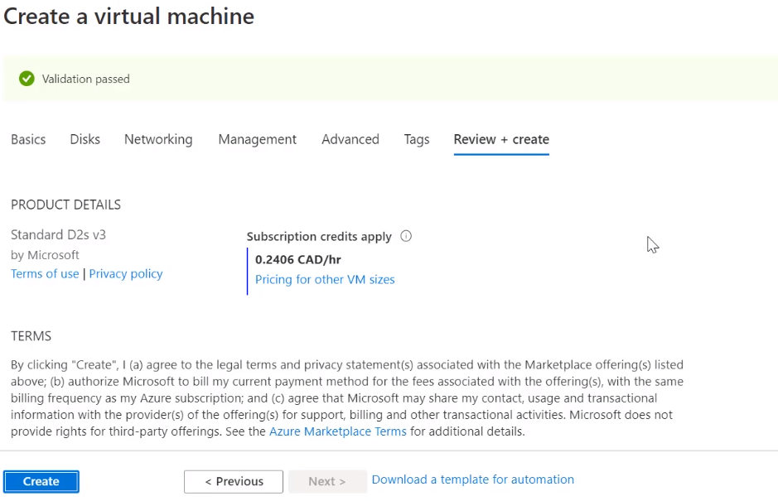

Create

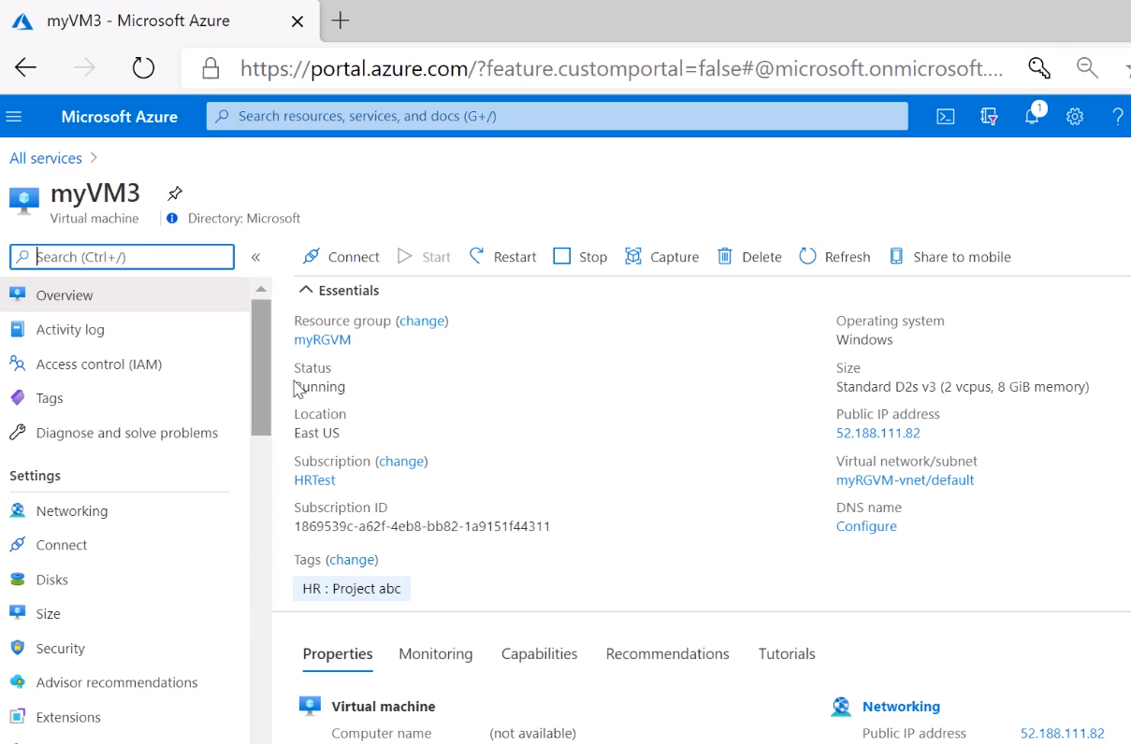

Connect window

RDP (cos opened that port)

Download file

Connect

Sign in as the Admin user you setup above

In VM

Can run any progs

Powershell

Install Windows management tools

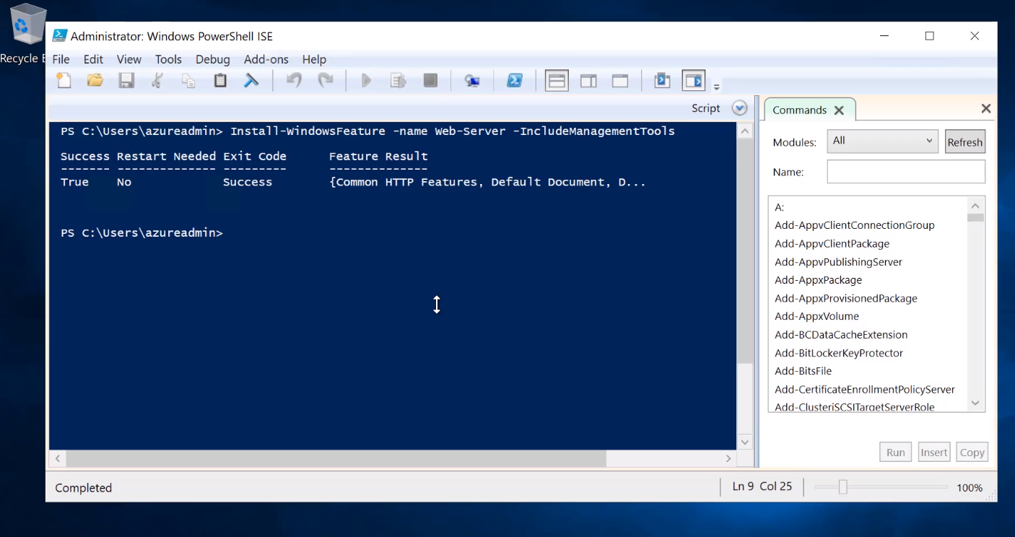

In Azure get the VM IP – copy

Paste into Web browser

Connects to VM from web

## PaaS

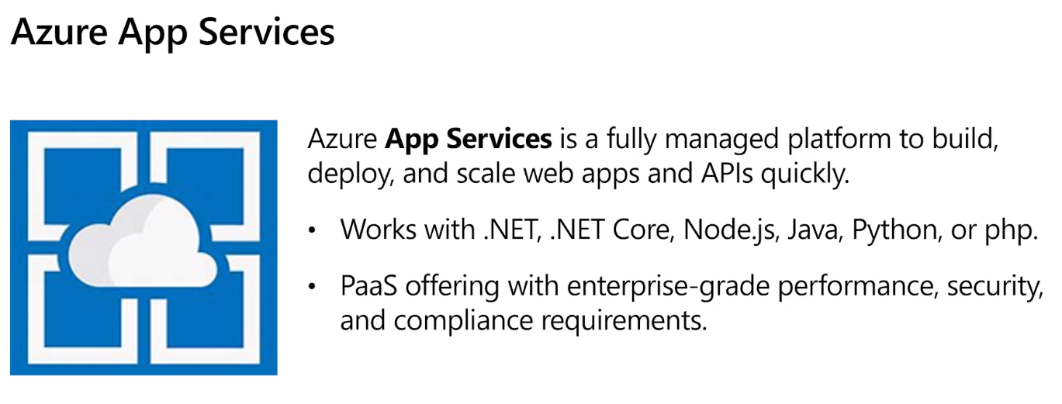

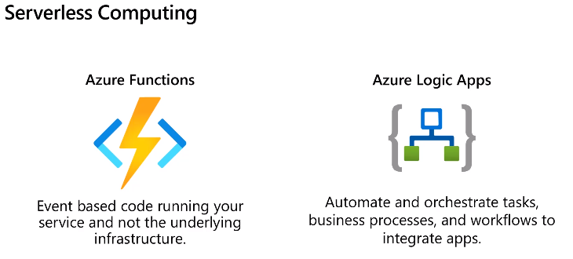

Functions – run code and forget about app

Stateless tasks

Logic apps start with a trigger

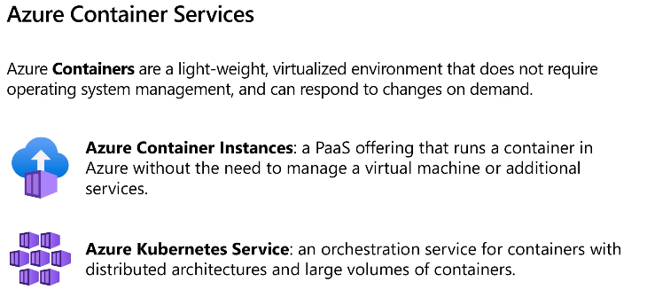

Azure Container Instance (ACI) as needed run continually and short bust or continuously

Kubernetes – used to deploy updates, run auto jobs, etc

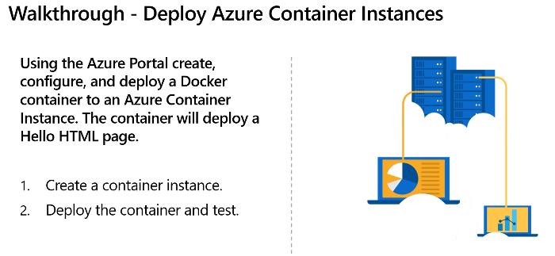

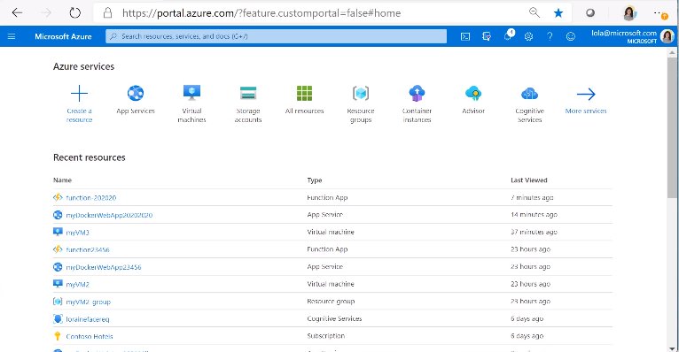

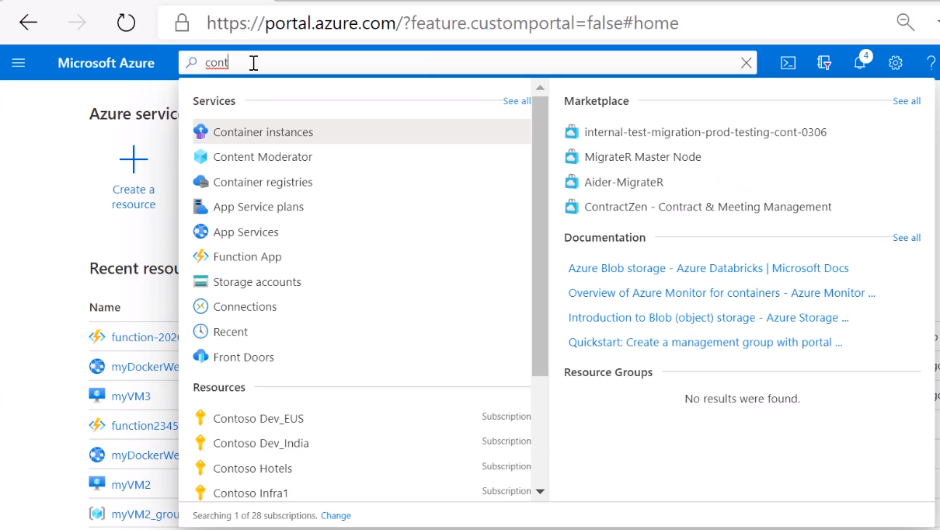

Add

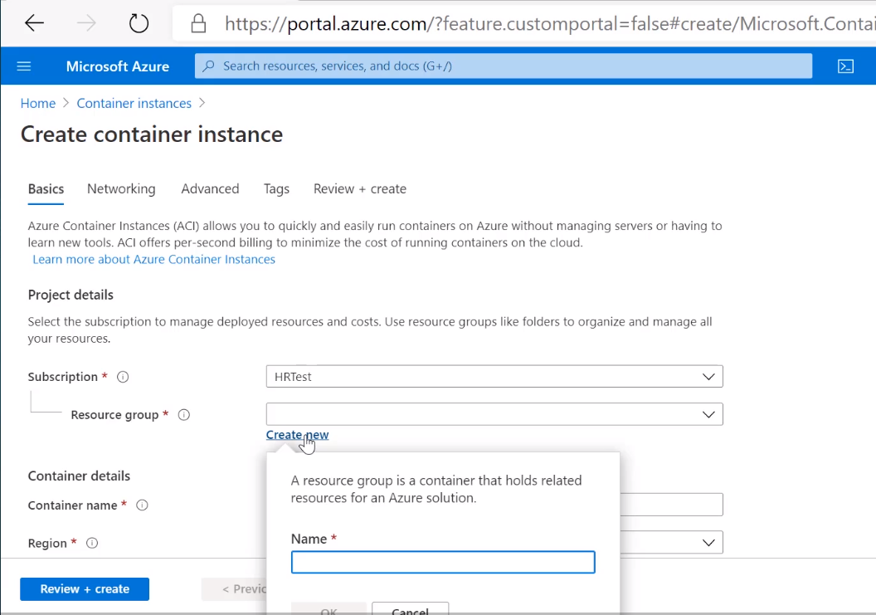

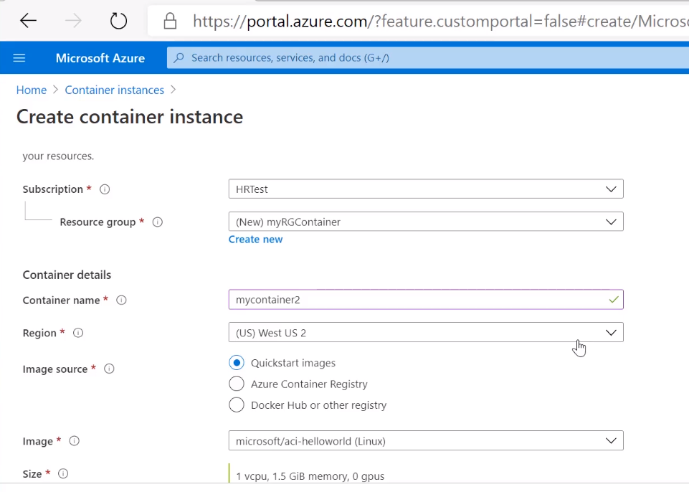

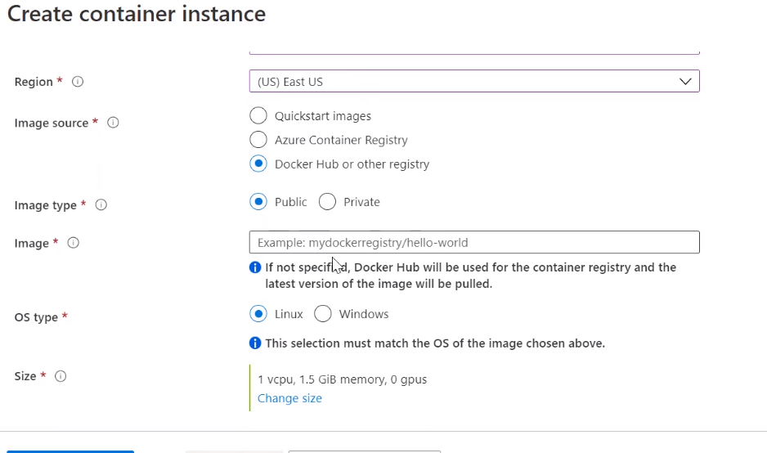

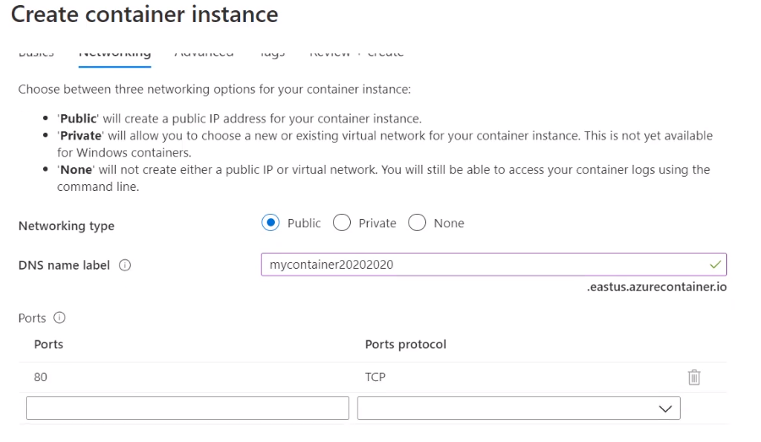

DNS name must be globally unique

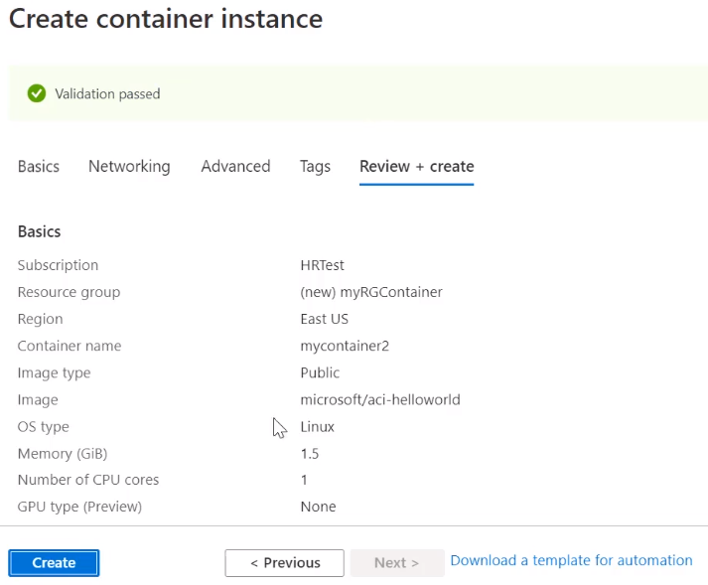

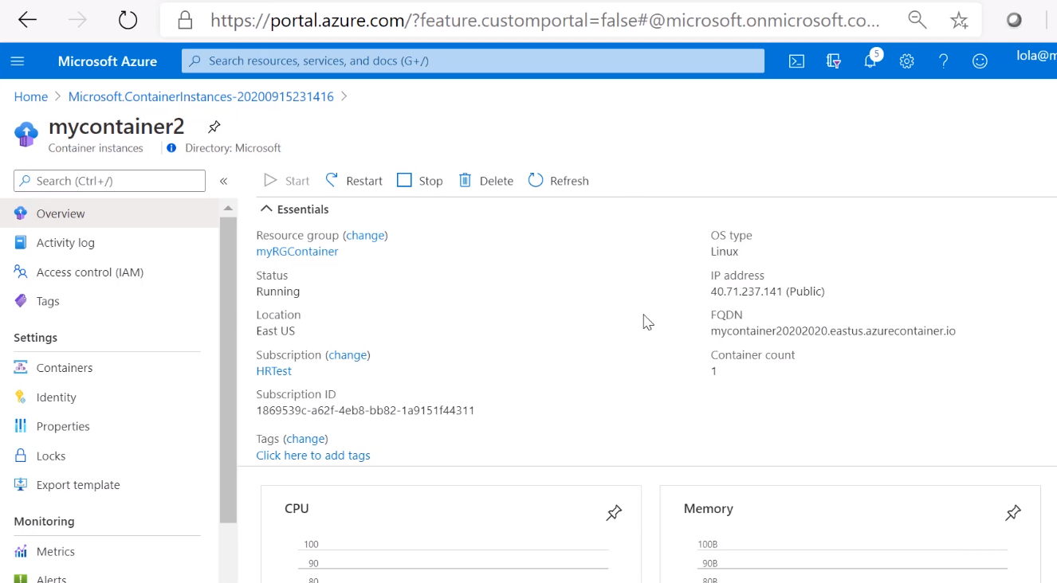

Use name on RHS to get link

Got to browser and paste

Can now connect to container

## Windows Virtual Desktop

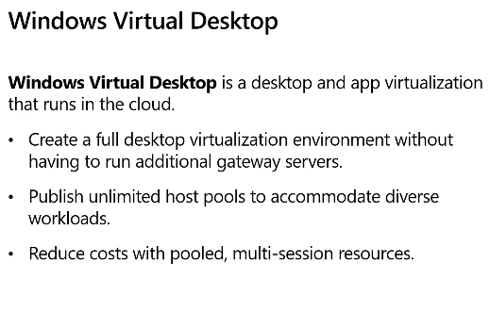

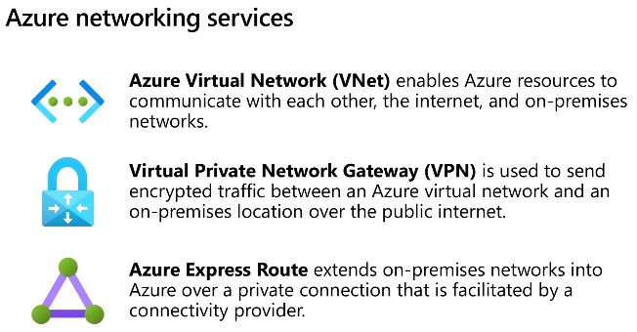

### Virtual Network & Machines

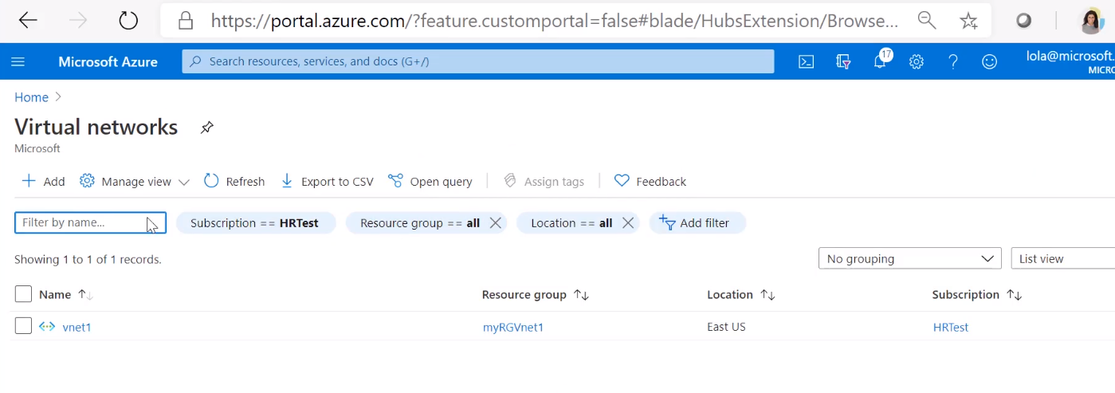

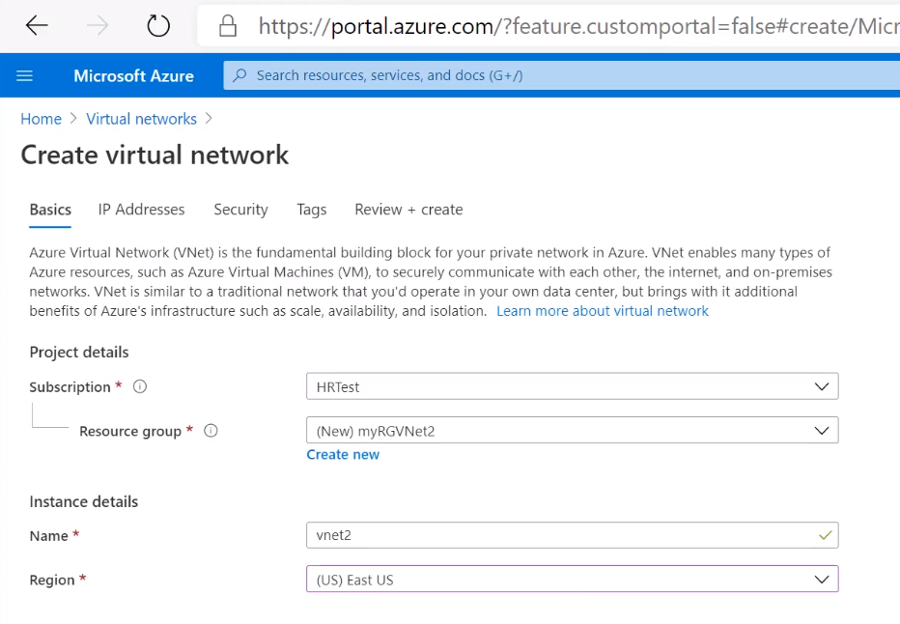

Chose all defaults including IP address

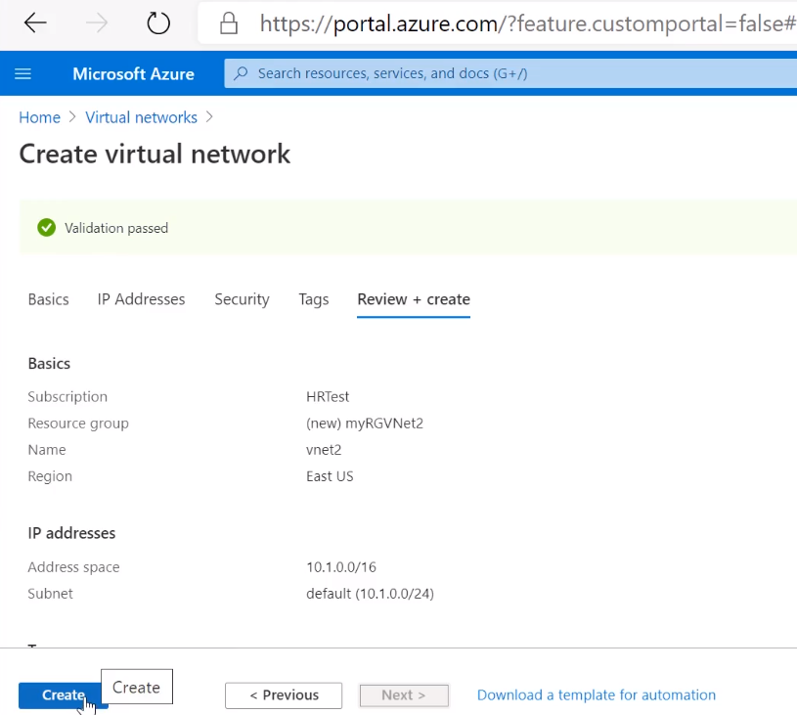

In your Virtual network, create virtual machines

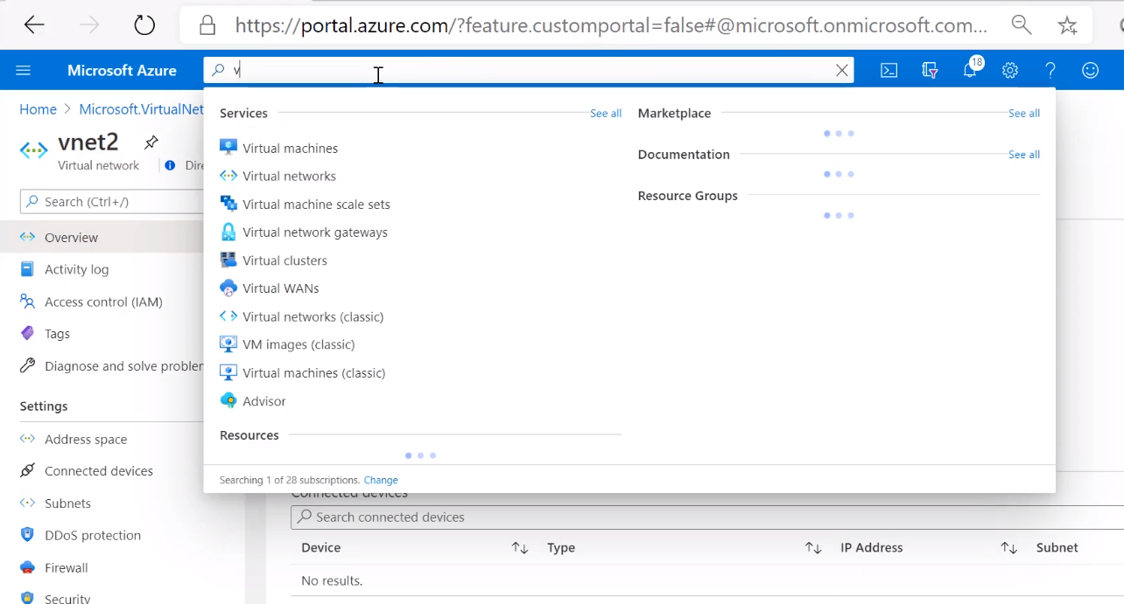

Use same resource group as before and add both VMs to same group

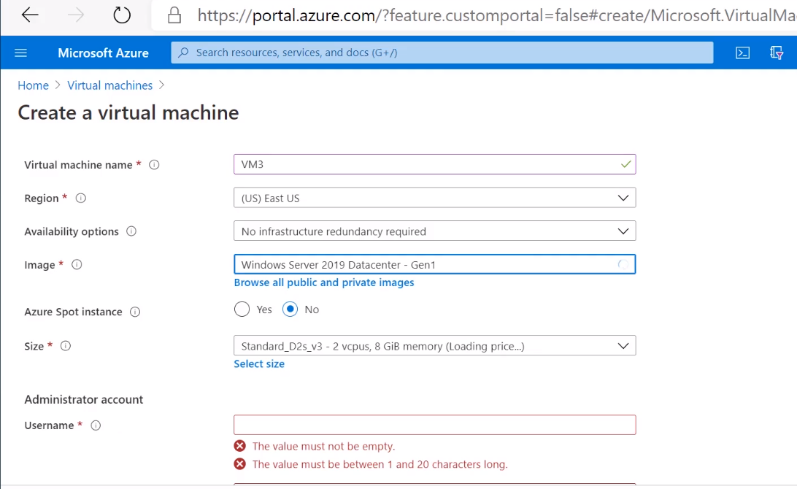

Choose ports that can access the VM

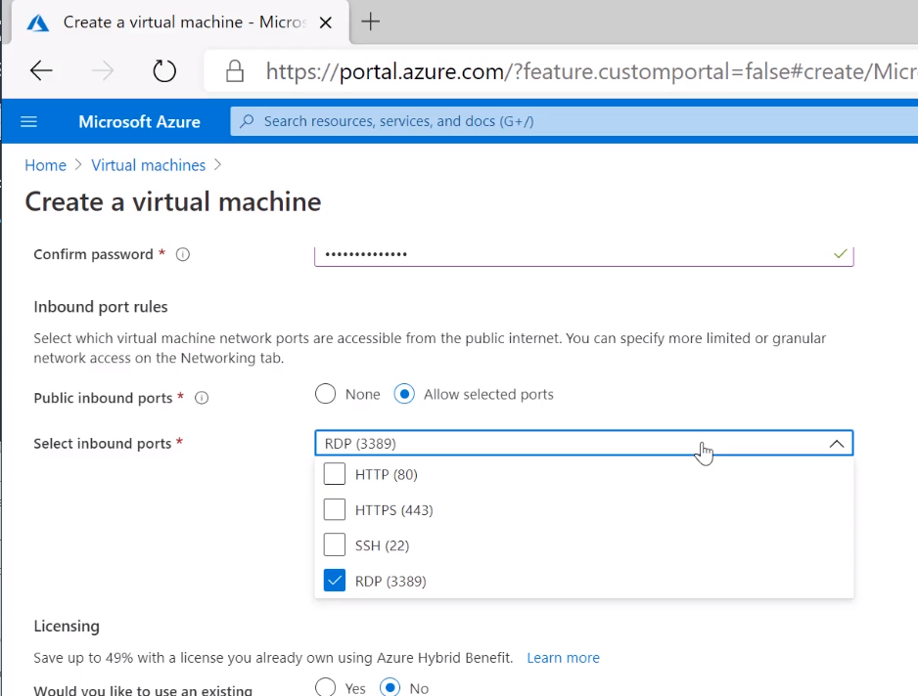

Choose networking

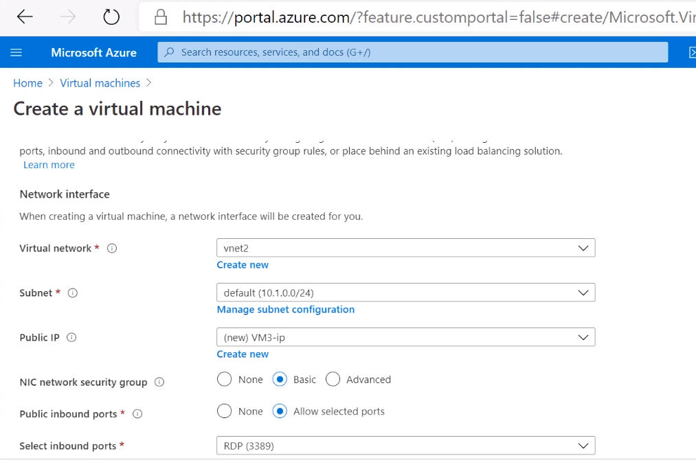

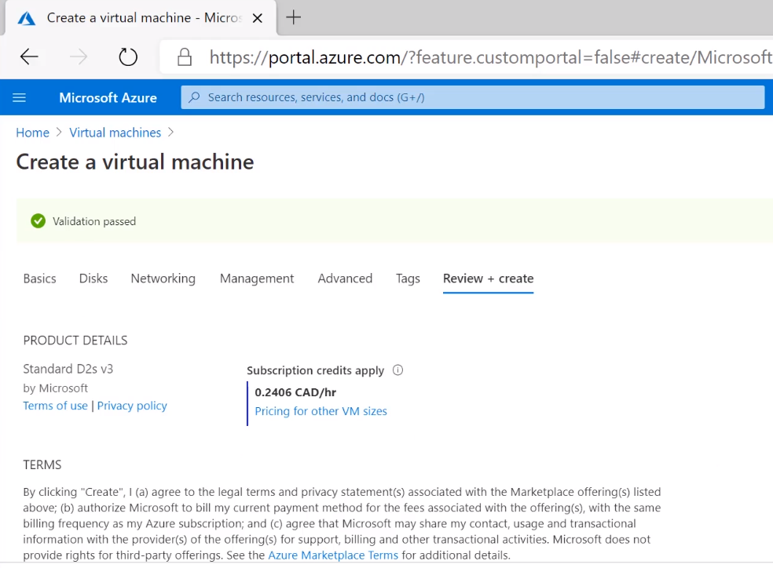

Go to Resource to verify

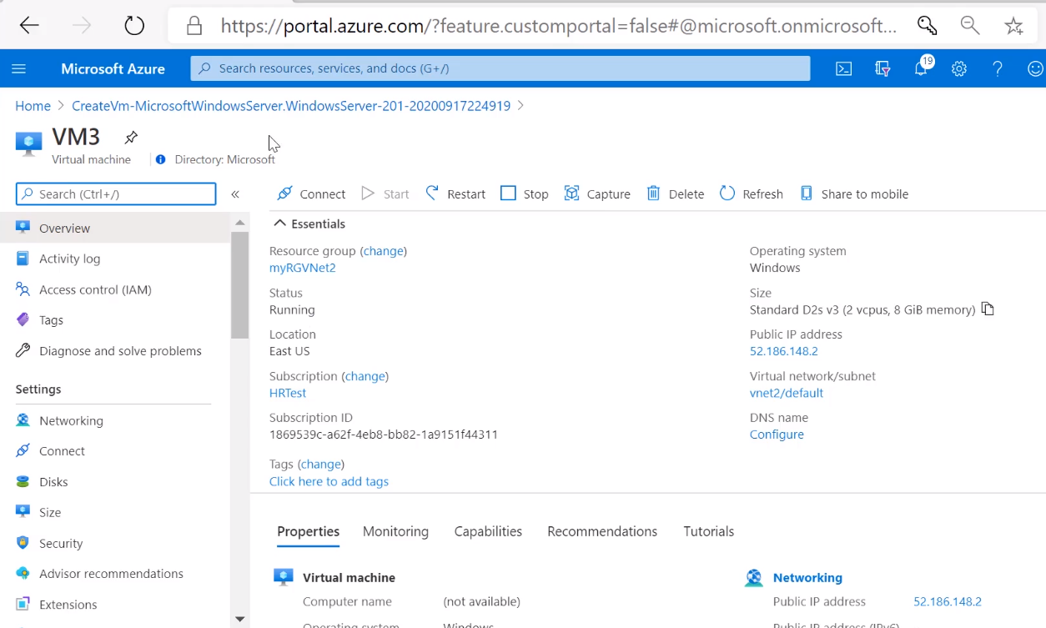

Same with a 2nd VM

Same resource group

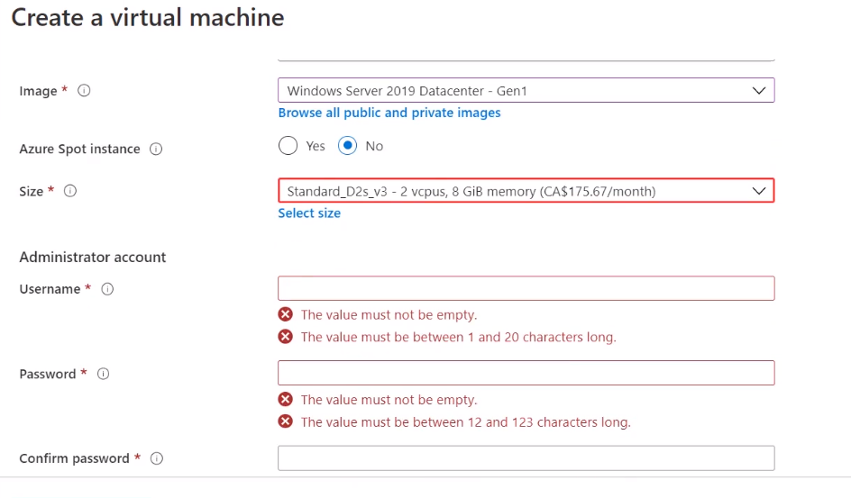

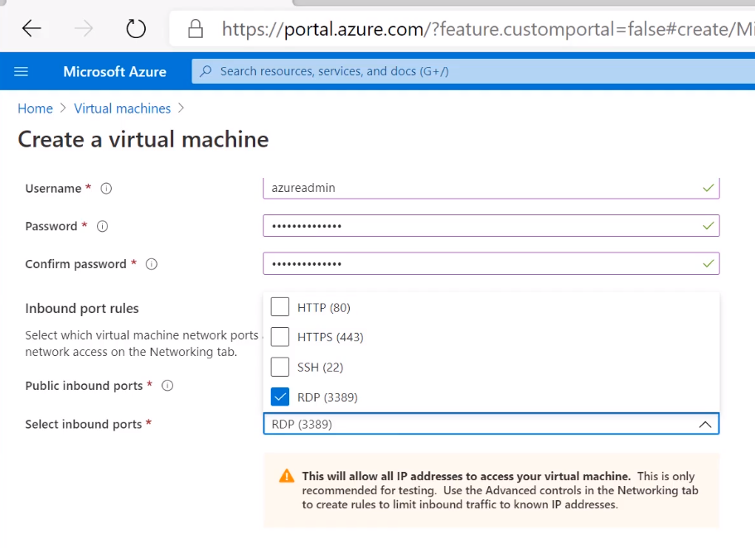

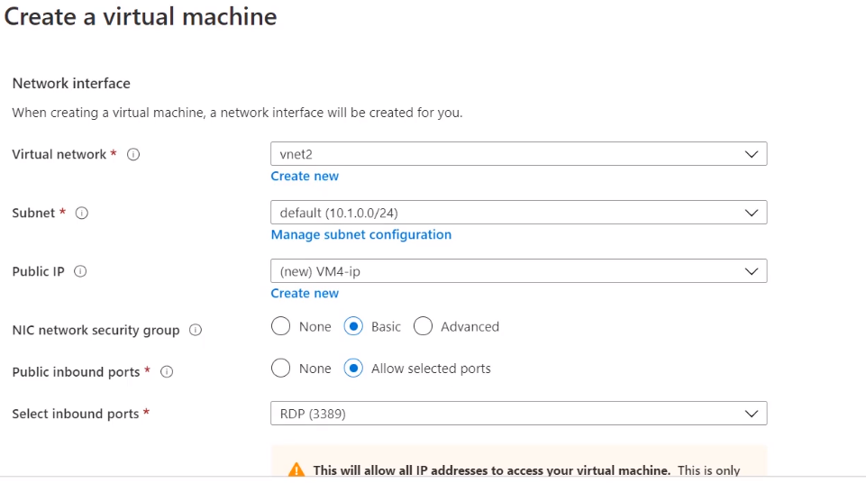

Review & Create

Go to resource and check running

Click the connet button

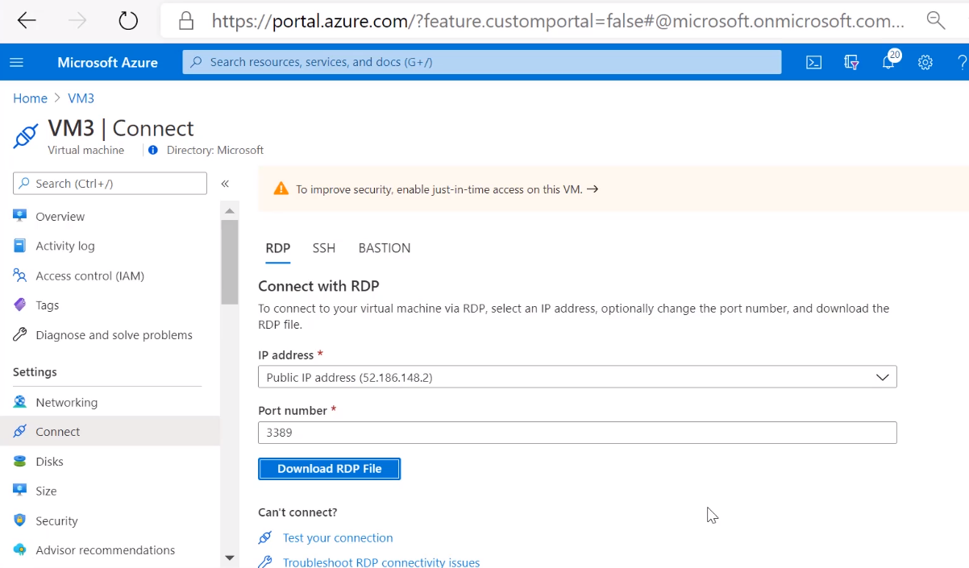

Download and open file

Sign in with username/pass create – Azure sign in

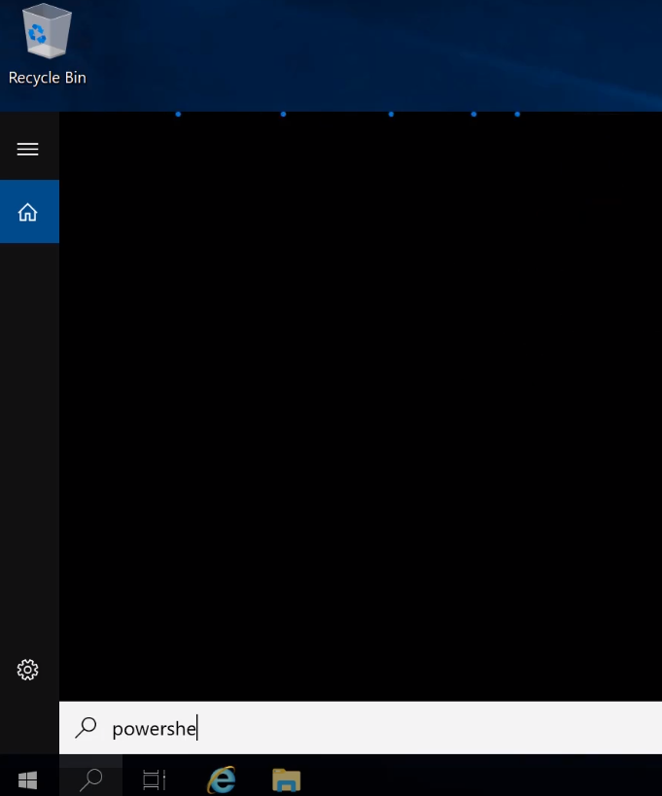

Sign in as Admin

Ping the other VM created

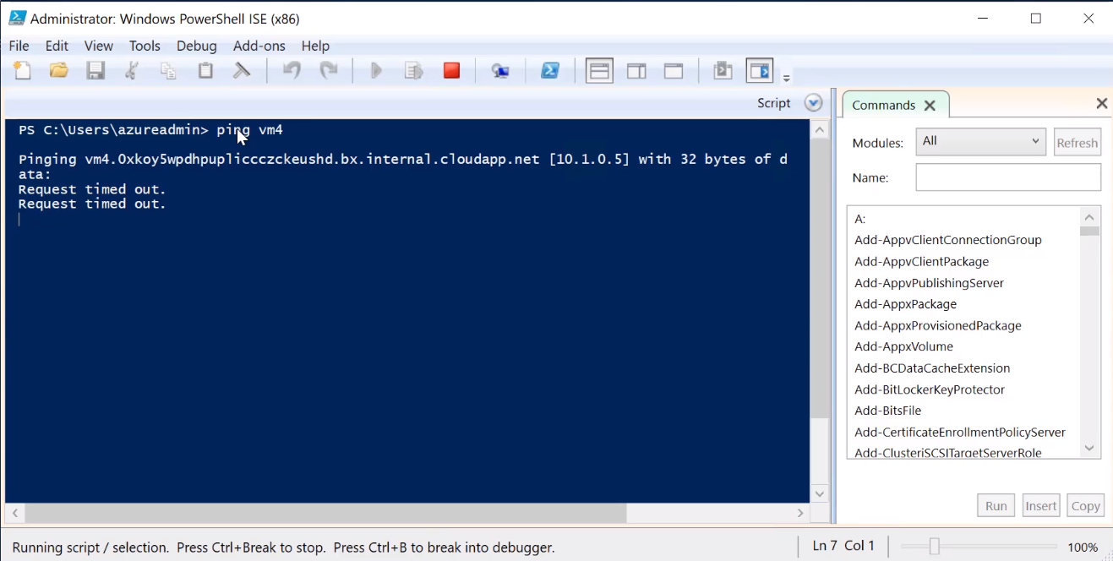

Fail because auto blocks ICMP requests

Go back to Azure portal and find VM to allow ICMP requests

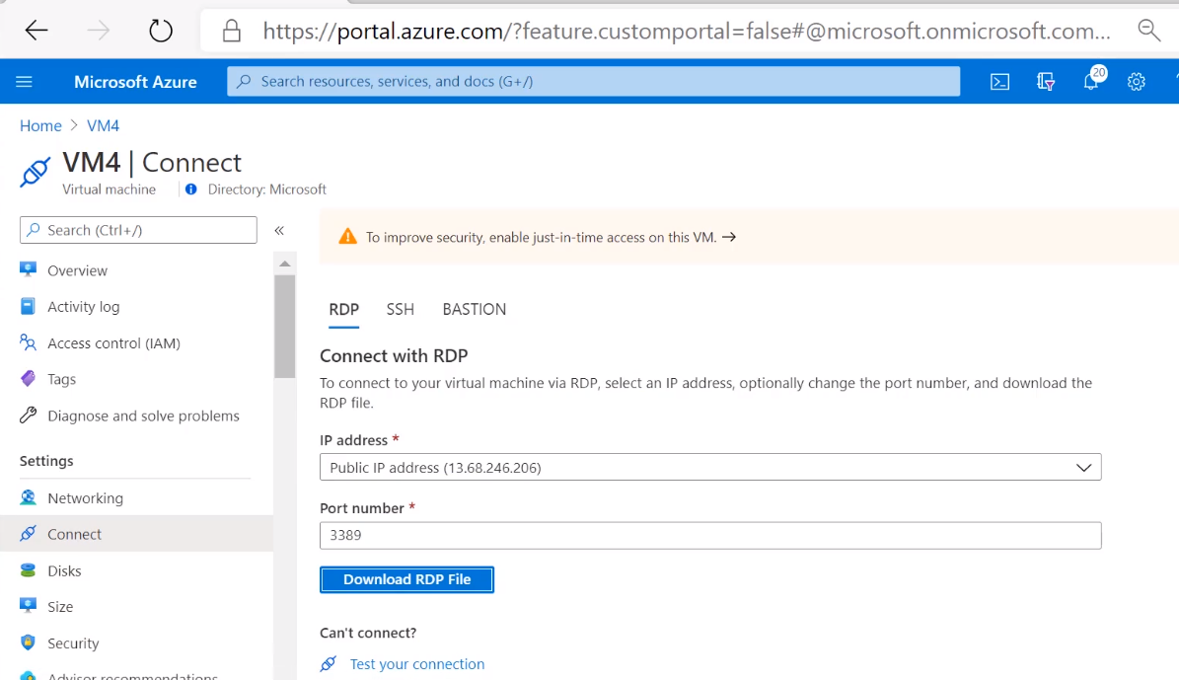

Download RDP file

Sign in to Azure

Run powershell again

Run as Admin

Type command to allow ICMP

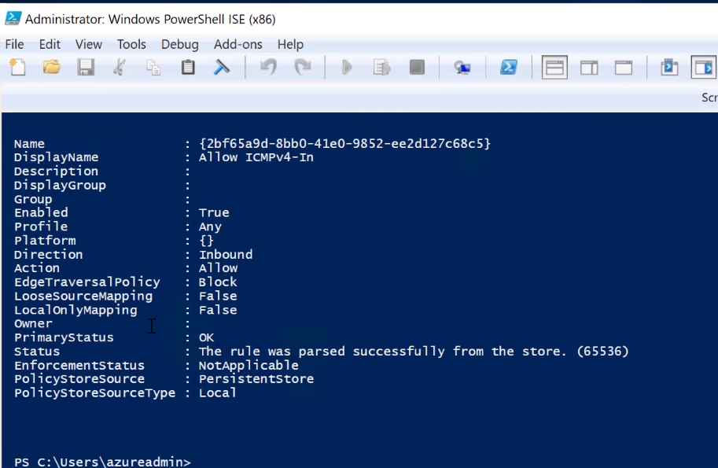

Log back in to other VM (3) and ping again to see if now allows connect

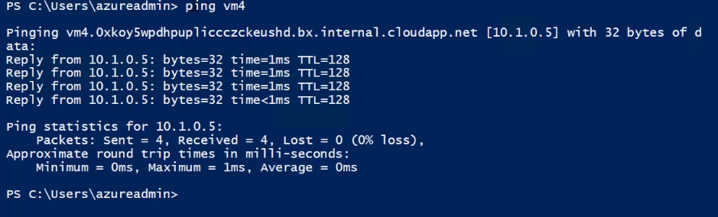

## Azure Database Services

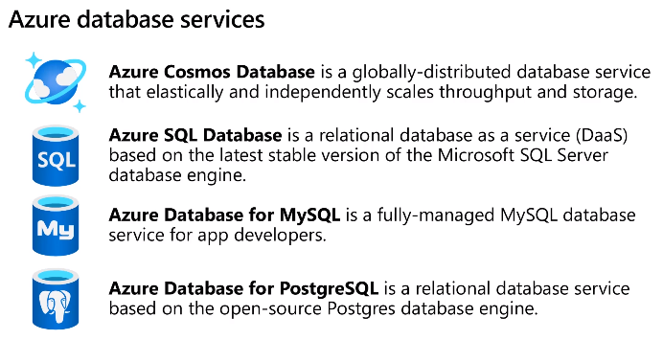

Also have fully manages database migration service

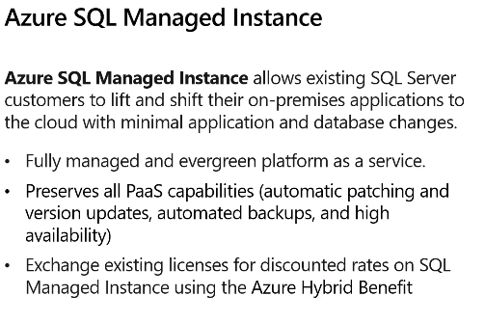

Easy lift and shift from on-prem to cloud

## Azure Marketplace

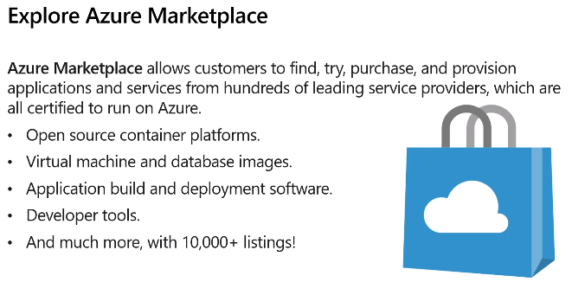

Find it in Azure Portal

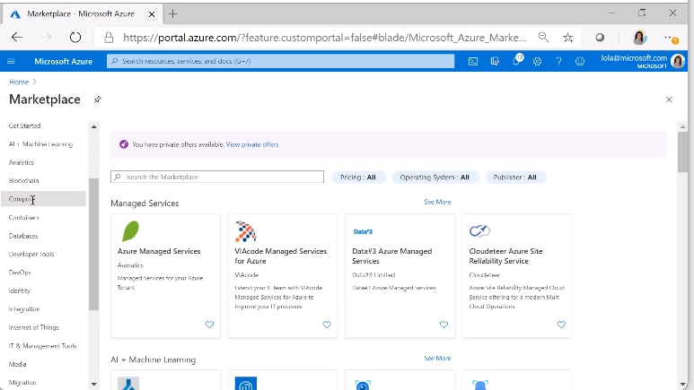

10,000 products and services

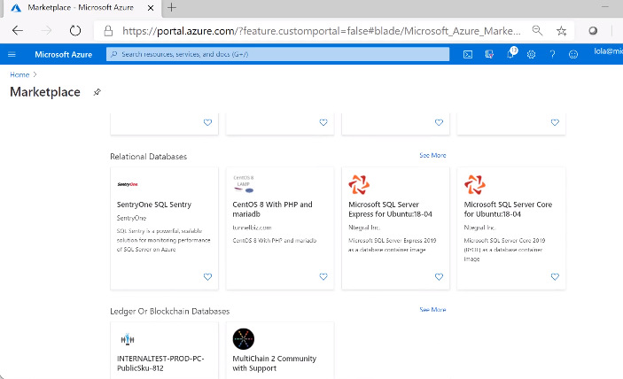

# Module 3 - Azure Solutions and Management Tools

## Internet of Things

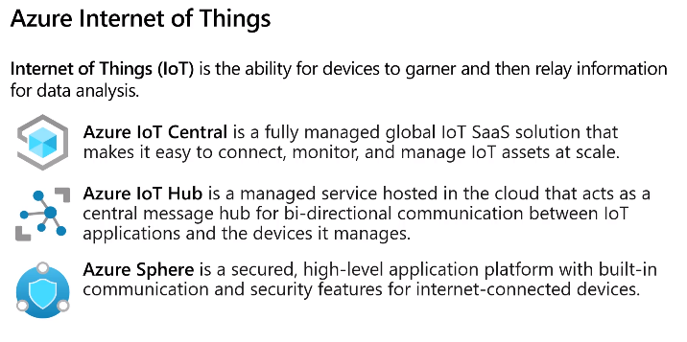

IoT Central – no tech required

IoT Hub – connect to anything and can hadle loads data

## Big Data Analytics

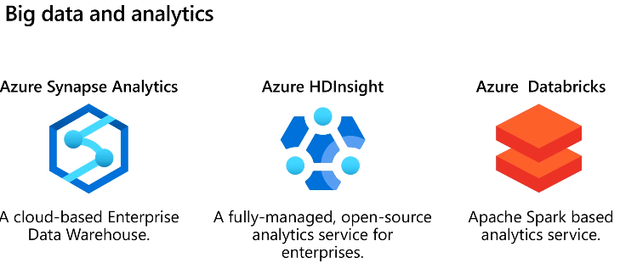

Analytics – includes AI & ML

HDInsights – runs opensource frameworks, creates clusters incl Apache spark, Hadoop, etc

Bricks – python, scalar, java, etc

### AI & ML

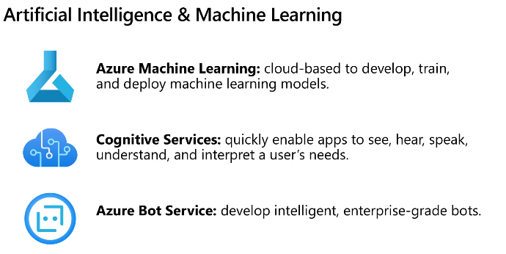

Machine learning studio will get you started, drag and drop

For all this slide see AI course undertaken last week.

## DevOps & GitHub

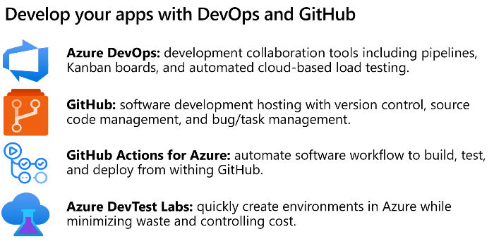

## Azure Management Tools

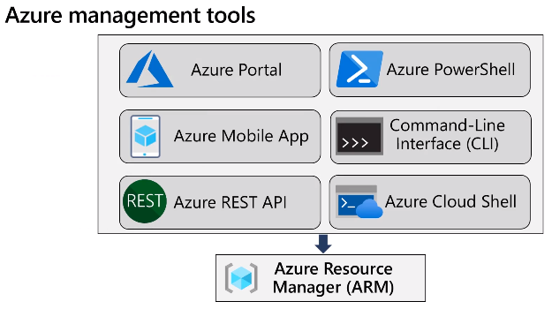

Powershell lets you manage Azure resources

Azure Cloud Shell – scripting (bash or powershell)

Resource manager allows auto deployment and management of resources

## Azure Resource Manager (ARM)

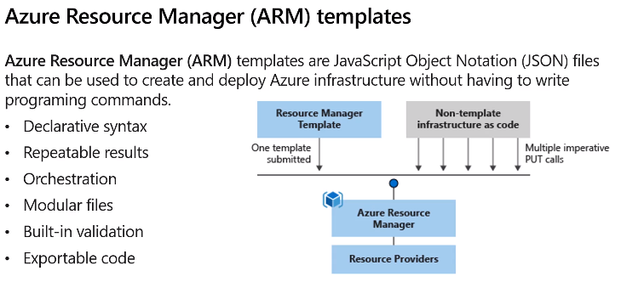

In Azure Portal

To go into Powershell to write code

Create storage account to store code

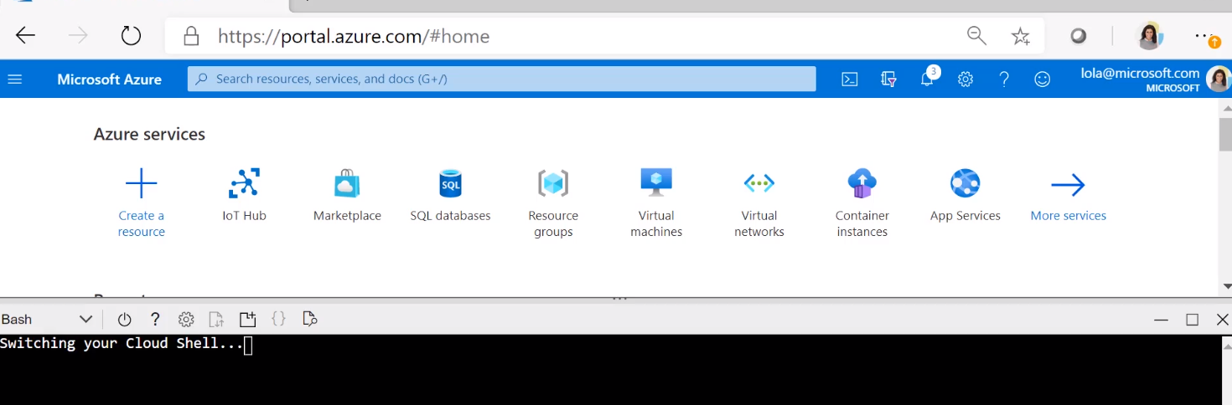

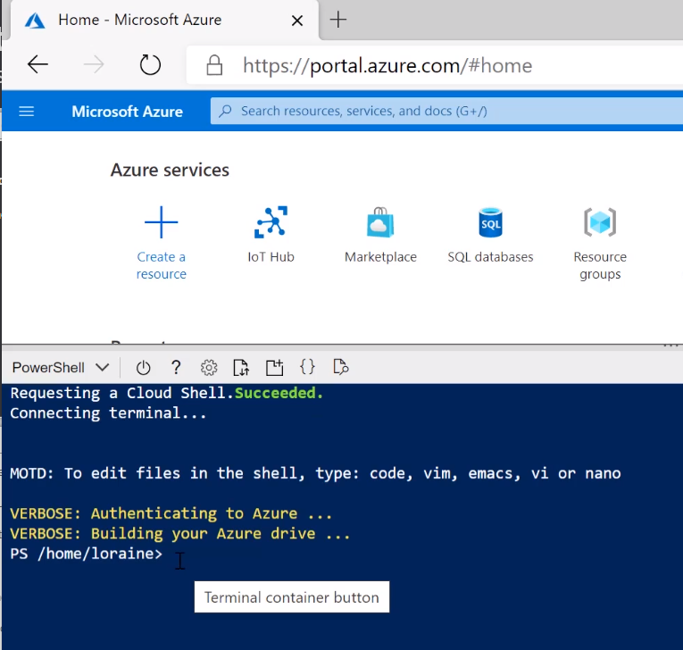

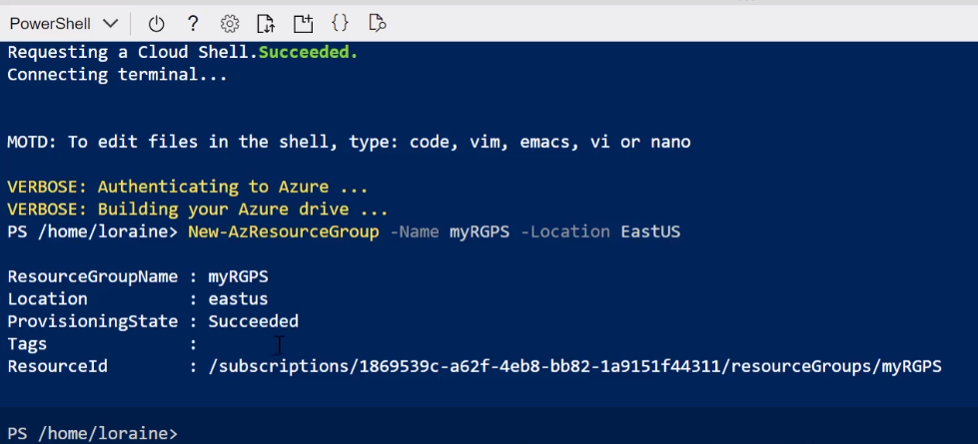

Check rsource group created

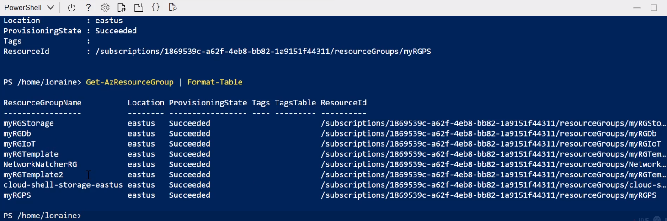

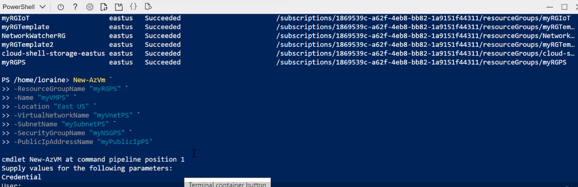

Insert user/pass

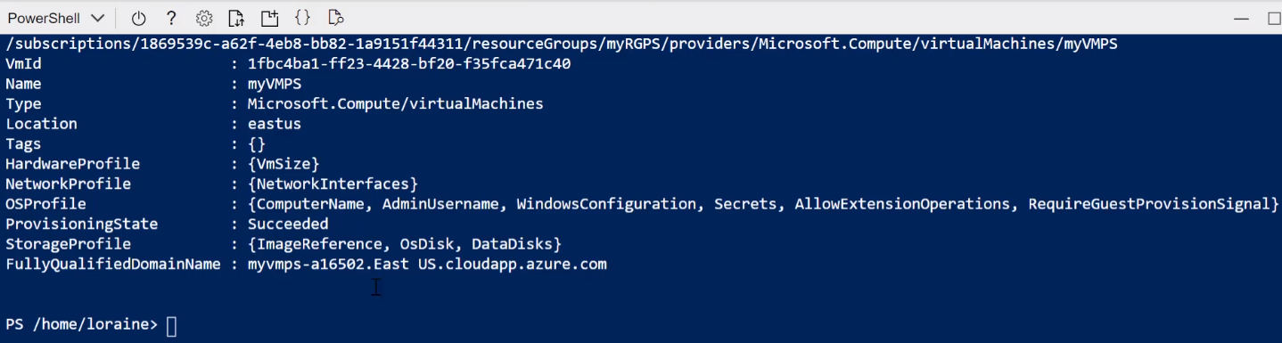

Search for myvmpowershell

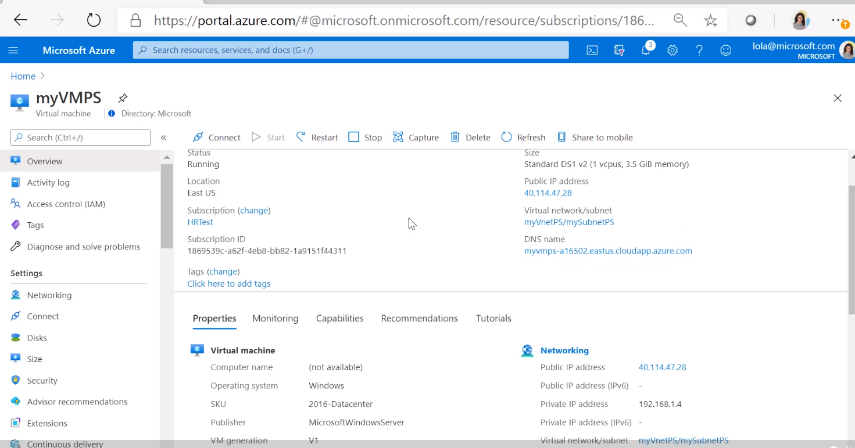

Check info on powershell VM

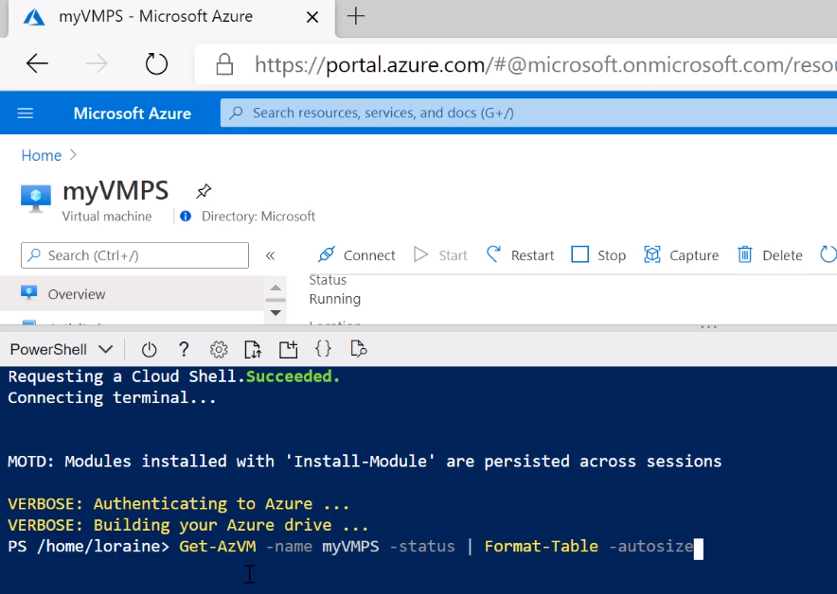

Stop VM

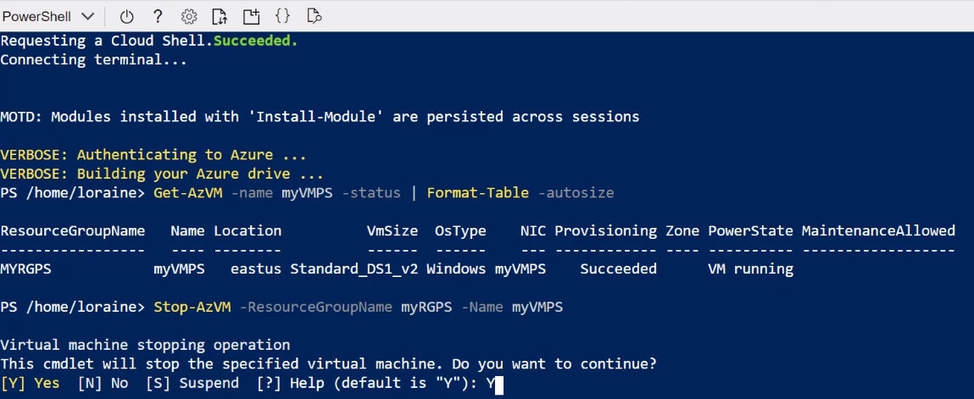

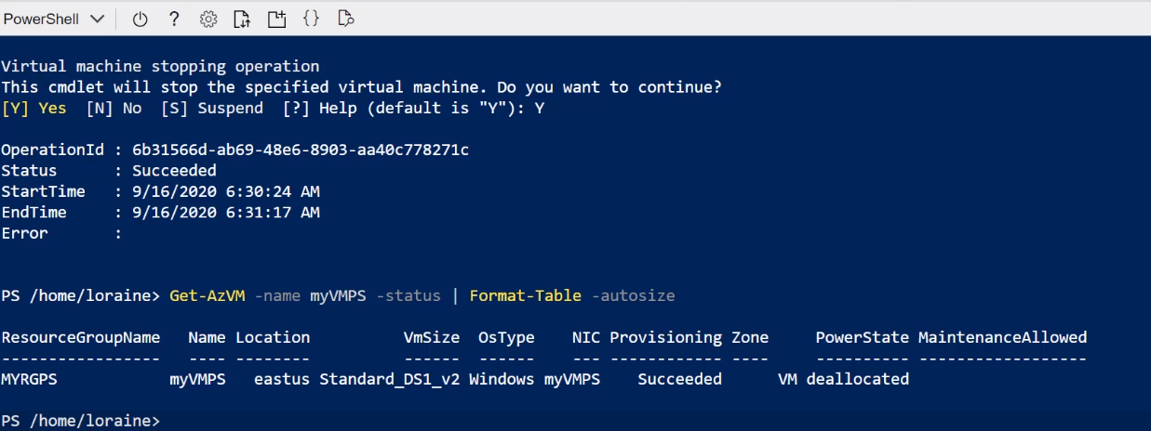

Back to portal – refresh nd see it has stopped

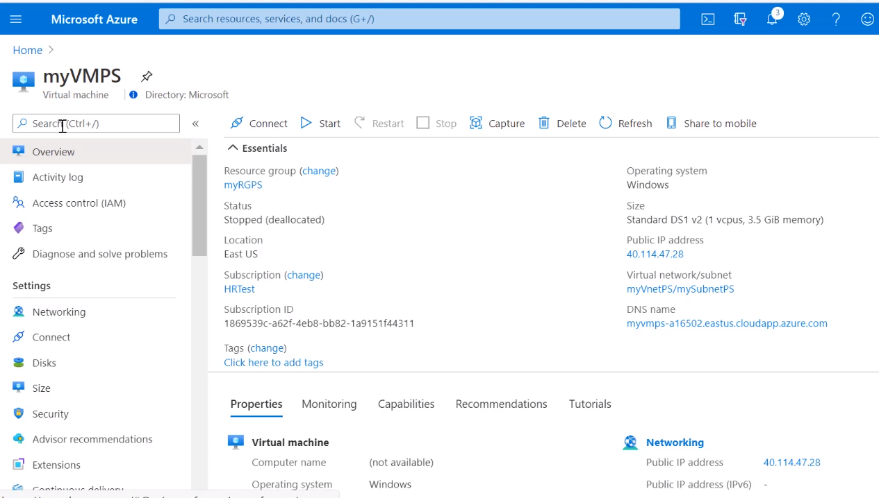

## Advisor in Azure Portal

Checks resource to advise on efficiencies and money saving

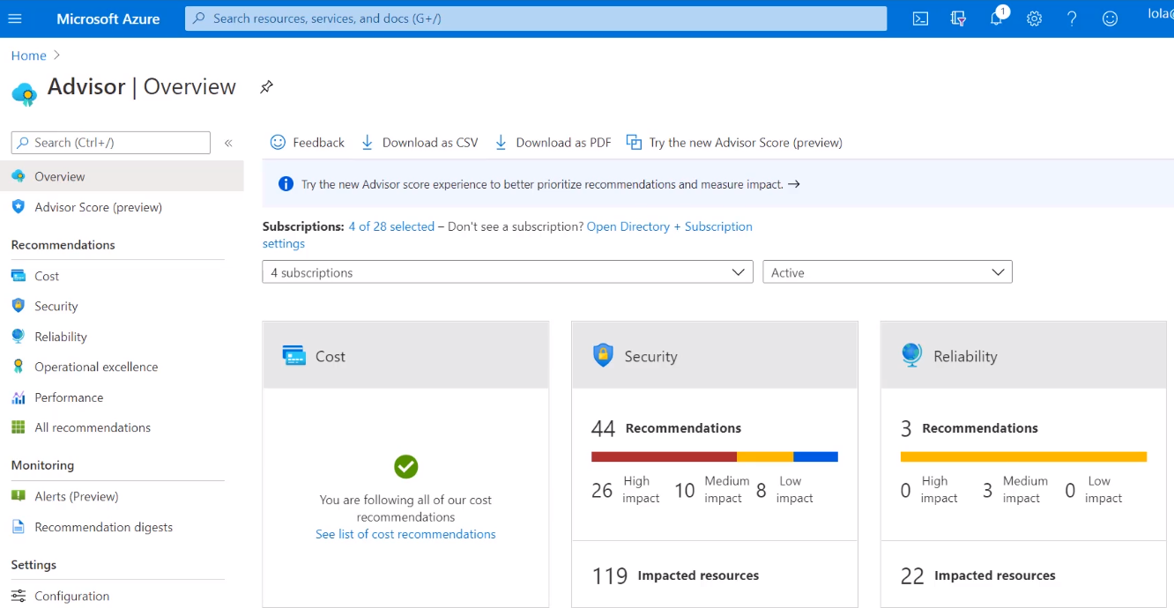

Select to drill down and see the details and impacts and remediation steps

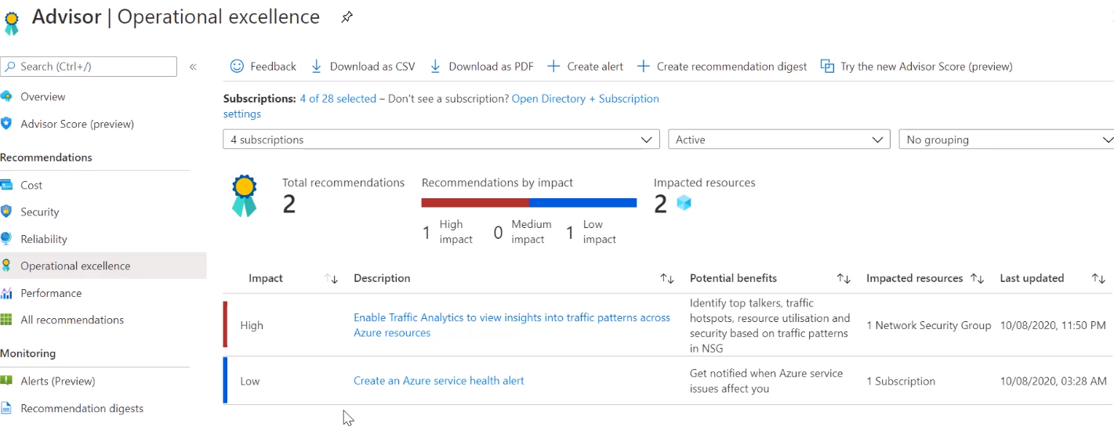

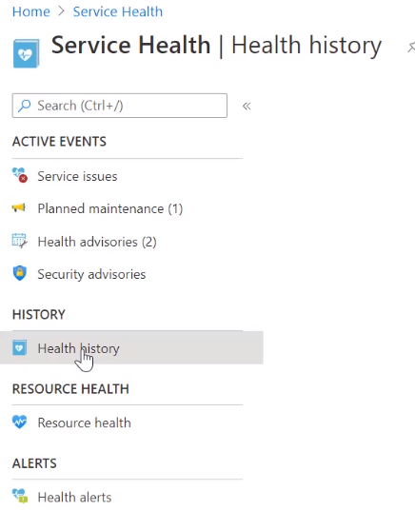

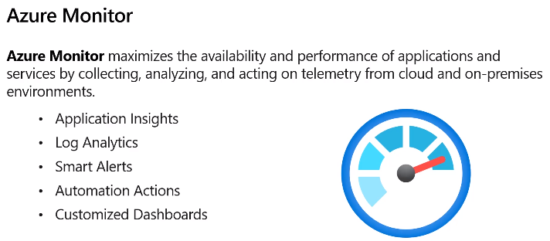

As soon as have resource the monitor auto collects data to report and can setup your own monitors